UNIT 3
Physical Properties and Changes

KEY IDEAS
Vocabulary | What does it mean? | Example
hypothesis
experiment
observation
data
law
theory
qualitative observation
quantitative observation
chemical property
physical property
hardness
malleability
ductility
luster
diffusion
vapour

KEY IDEAS
Vocabulary | What does it mean? | Example
matter
element
compound
atom
molecule
ion
(anion, cation)
particle
homogeneous substance
heterogeneous substance
pure substance
mixture
mechanical mixture
solution
solvent
solute
hand separation
filtration
evaporation

KEY IDEAS
Vocabulary | What does it mean? | Example
distillation
solvent extraction
immiscible
miscible
chemical change
physical change
melting
freezing
sublimation
deposition
condensation
melting point
freezing point
boiling point
condensation point
kinetic energy

3.0 - Classification of Matter

Matter: anything that has _________________ and ______________ (takes up space)
- exists in three states (or phases)

Solid  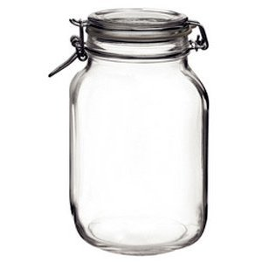  - particles are packed tightly  - low kinetic energy  - fixed shape  - not compressible | Liquid  - particles packed less tightly  - more kinetic energy  - shape depends on container  - not compressible | Gas  - particles are very spread out  - higher kinetic energy  - shape depends on container  - compressible

- matter is made of particles

atom | molecule | cation | anion

- the appearance of matter can be described as
The substance looks the same everywhere  (_________________________________). The substance only contains _________________.  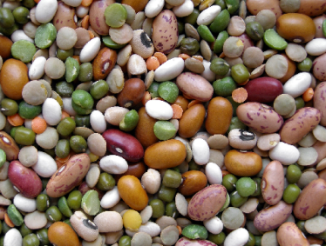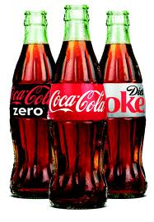 | The substance doesn’t look the same everywhere  (_________________________________). The substance may contain _____________________.  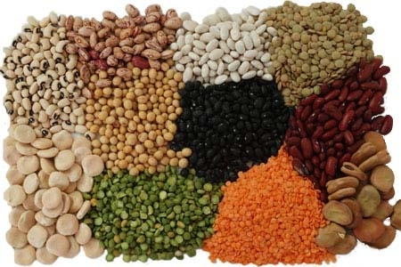

Activity: Classification of Matter

Matter can be classified depending on the composition.
- Match each classification with the correct description and example.
- Arrange the classifications into a flow chart on the next page.

Description |  | Classification |  | Example
Made of a single type of atom |  | Matter |  | Ca, Na, Pb, Cu, Cr
Anything that has mass and volume |  | Pure substance |  | Iced tea, saline drip, rubbing alcohol
Elements that are on the left side of the periodic table. They usually are solids, shiny, and can conduct electricity. |  | Mixture |  | Au, Kr, Ag, O
Made of a single substance with constant (uniform) composition throughout |  | Element |  | Any substance in the universe
Has more than one substance. Some substances can be physically separated by hand. |  | Compound |  | Water, vinegar
Made of more than one substance with variable composition throughout. |  | Solution |  | C₂H₂, SiO₂, CO₂
Has undissolved fine particles in a liquid. Under the right conditions, the particles can settle to the bottom. |  | Suspension |  | Fried rice, sediments
Has a substance uniformly dissolved in a liquid. The substance will not settle. |  | Mechanical mixture |  | Sugar water
A particle made of a metal and a non-metal bonded together. |  | Metal |  | Muddy water
A particle made of more than one type of atom |  | Non-metal |  | NaCl, SiO₂, Li₂O, N₂
Elements that are on the right side of the periodic table. They generally cannot conduct electricity. |  | Ionic compound |  | NaCl, MgO, Ag₂O
A particle that is made of a non-metal bonded to other non-metals. |  | Covalent compound |  | O, N, F, Cl, Br, S, He

Classification of Matter

3.1 - Separation Techniques

 | Diagram |  | How Does it Work? | Types of mixtures for this technique?
Hand Separation
Filtration | 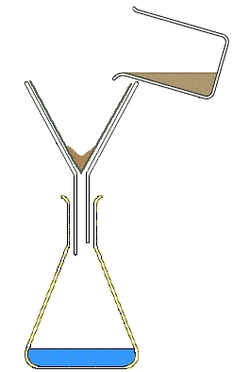  filter paper  mixture  residue  funnel  filtrate
Evaporation | 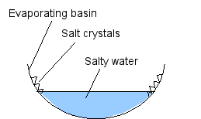
Distillation | 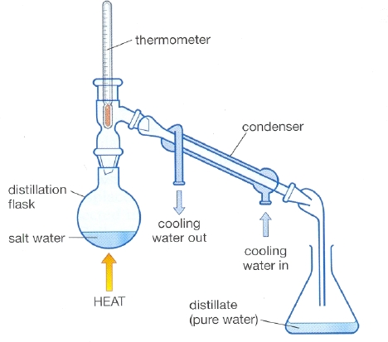
Solvent Extraction
Recrystallization
Gravity Separation
Chromatography | 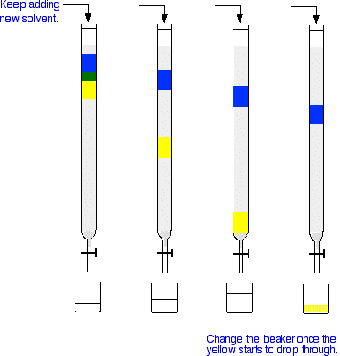

3.2 - Changes in Matter

There are two types of changes matter can undergo.

PHYSICAL CHANGE | CHEMICAL CHANGE
What is it?  - no _____________________ formed  - is a change in the _________ of a substance  How it occurs:  - ____________________ bonds are broken  - the distance between molecules changes  How do you know if a change is physical:  - no new colour  - no new smell  - change in shape  - change in state/phase  Examples:  - mixing things together  - __________________________  - phase change  Types of phase changes:  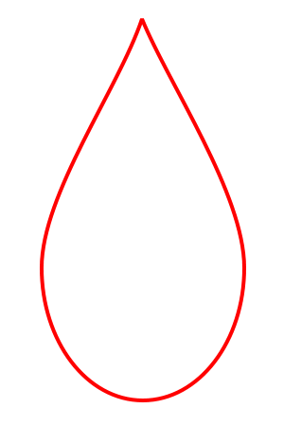 | What is it?  - new _____________with new ___________ are formed  How it occurs:  - ____________________ bonds (chemical bonds) are broken  - atoms are rearranged  How do you know if a change is chemical:  - new smell  - new colour  - heat/light might be given off  - bubbles or gas formed  - solid material forms in liquid (precipitate)  - difficult to reverse (undo)  Examples  - burning  - explosions  - stove top cooking  Types of energy changes:  - exothermic: releases heat (KABOOM!!)  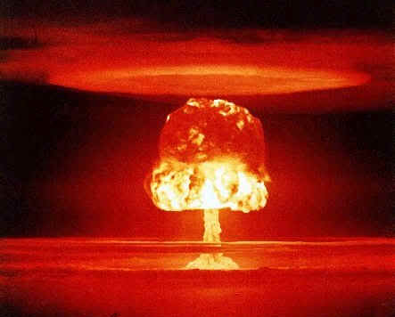  - endothermic: absorbs heat

3.3 - Heating Curves

- kinetic energy is energy that molecules possess as a result of motion
- average kinetic energy = __________________
- we can plot KE vs. time to obtain a heating curve

Heating Curve of Chemical X
140
120
100
Temp.
(°C)
80
60
40
20
0
-20

Time (min)

A/C/E:
- kinetic energy (temperature) increases
- distance between particles begins to increase

B/D:
- substance is absorbing heat to break ___________________ bonds
- all heat is used to break these intermolecular bonds, so temperature stays _______________
- when intermolecular bonds are broken, we get a phase change

_____________________ undergo phase changes in fixed temperatures:

Melting point (m.p): temperature at which (solidliquid)
Freezing point: temperature at which (liquidsolid)
Boiling point (b.p): temperature at which (liquidgas)
Condensation temperature: temperature at which a (gasliquid)

