UNIT 6
Stoichiometry

KEY IDEAS
Vocabulary | What does it mean?
stoichiometry
excess reagent
limiting reagent
percent yield

6.0 – Mole Bridge

Stoichiometry: the __________________ between __________________________

Example: What are the stoichiometric ratios of the reaction H₃PO₄ + 2KOH → K₂HPO₄ + 2H₂O?

If we react 1 mole of H₃PO₄ with 2 moles of KOH, we will produce ______ mol of K₂HPO₄ and ______ mol H₂O

If we want to produce 10 mol K₂HPO₄, ______ mol of H₃PO₄ is needed, along with ______ mol of KOH

It is possible to calculate how much product is produced knowing how much reactants we start with, or vice versa (the other way around).
- stoichiometry is always done with __________, _________________ or ______________ for gases
- mole ratio/molecule ratio/volume ratio, ________________________________
- the conversion factor is equal to the mole ratio between two species

Practice: Consider the reaction N₂ + 3H₂ → 2NH₃ for the following questions.

- How many moles of NH₃ are produced when 18 mol of H₂ are reacted?

- How many molecules are N₂ are required to react with 15 molecules of H₂?

- How many moles of NH₃ is produced when 5.11 g of N₂ has reacted?

- How many grams of NH₃ is produced when 7.22 g of N₂ has reacted?

- How many molecules of N₂ have reacted when 2.00 g of NH₃ is produced?

Practice: Consider the reaction C₃H_{8(g)} + 5O_{2(g)} → 3CO_{2(g)} + 4H₂O_{(l)}

- What volume of O₂ at STP has reacted if 10.0 L of CO₂ at STP was produced?

- What mass of H₂O is produced if the reaction also produced 50.0 L of CO₂ at STP?

QUESTION | ANSWER

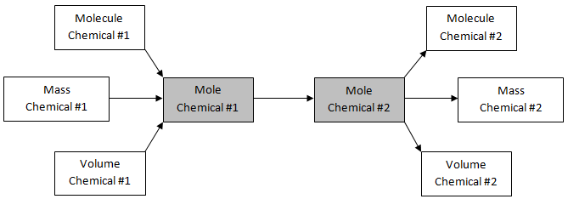

6.1 – Limiting Reagents

Suppose you want to make a bicycle. You need one frame, one bell, one handlebar, and two tires.

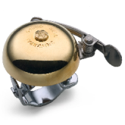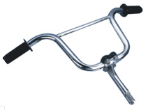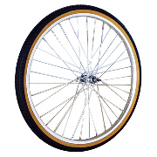
+ 2
+
+

How many bicycles can you make from the following?

Bell | Frame | Handlebar | Tire | Bicycles | Limited By | Excess
1 | 1 | 1 | 2 |  | - | -
10 | 2 | 5 | 20
55 | 22 | 20 | 10

In chemical reactions, there is often one or more excess reactants because
- one of the reactants is really expensive so you want to make sure ALL of it is used up
- you only have a limited amount of one reactant

excess: ______________________________

limiting reagent: the reactant that is ________________ used up in a reaction

How do you find which reactant is the limiting reagent?
- method 1
  - main method
  - calculate the amount of product produced using each reactant given
  - the reactant that produces the least number of product is the limiting reagent
- method 2
  - calculate the number of moles of each reactant
  - compare the mole ratio you have to the mole ratio in the reaction
- method 3
  - good if you just want to find which reactant is the limiting reagent
  - choose 1 reactant and calculate how much of the 2nd reactant is needed
  - compare this number with how much of the 2nd reactant you actually have

When trying to predict how much product you will get from a reaction, you must perform calculations using the limiting reagent

Example: 20.0 g of H_{2(g)} reacts with 100.0 g of O_{2(g)} according to the reaction 2H_{2(g)} + O_{2(g)} → 2H₂O_{(l)}.
- What is the limiting reagent?
- How much H₂O is made?
- How much excess of the excess reagent will be left over?

6.2 – Percent Yield

So far, all the calculations we did represent the perfect world, that all the reactants will be used up and turn into products. Is this ever true?
- all the reactants are ___________ (no contaminants)
- all the reactants will ______________________
- no errors in the experiment
- no reactants or products lost during the experiment (____________________________________ _______________________________________)

In the real word, the above conditions are ___________________________________.

This has 2 implications:
- you will always get ___________________ than you expect
- you will need to use _____________________ than theoretically ____________ to make what you want

Example: When 15.0 g of CH₄ is reacted with an excess of Cl₂ according to the reaction CH₄ + Cl₂ → CH₃Cl + HCl, a total of 29.7 g of CH₃Cl is formed. What is the percent yield of the reaction?

Example: What mass of K₂CO₃ is produced when 1.50 g of KO₂ is reacted with an excess of CO₂ according to the reaction 4KO_{2(s)} + 2CO_{2(g)} → 2K₂CO_{3(s)} + 3O_{2(g)} if the reaction has a 76.0% yield?

Example: What mass of CuO is required to make 10.0 g of Cu according to a 58.0% yield reaction
2NH₃ + 3CuO → N₂ + 3Cu + 3H₂O?

6.3 – Percent Purity

Example: If 100.0 g of FeO produces 12.9 g of pure Fe according to the reaction 2FeO + 2C + O₂ → 2Fe + 2CO₂ what is the percentage purity of the FeO used?

Example: What mass of pure Na₂CO₃ can be formed by heating and decomposing 5.00 kg of 79.4% pure trona, Na₃CO₃ HCO₃ · 2H₂O, according to the reaction 2Na₃CO₃ HCO₃ · 2H₂O → 3Na₂CO₃ + CO₂ + 5H₂O?

Example: What mass of impure zinc metal having a purity of 89.5% is required to produce 975 mL of hydrogen gas at STP according to the reaction Zn_{(s)} + 2HCl_{(aq)} → ZnCl_{2(aq)} + H_{2(g)}?

