|  |
| --- |
| UNIT 9  Solution Chemistry |

|  |  |
| --- | --- |
| **KEY IDEAS** | |
| Vocabulary | What does it mean? |
| VSEPR |  |
| dipole-dipole |  |
| London forces |  |
| Hydrogen bond |  |
| polar |  |
| solution |  |
| solvent |  |
| solute |  |
| dissolve |  |
| soluble |  |
| solubility |  |
| saturated |  |
| unsaturated |  |
| dilute |  |
| concentration |  |
| molarity |  |
| dilution |  |
| precipitate |  |
| formula equation |  |
| complete ionic equation |  |
| net ionic equation |  |
| conductivity |  |

|  |
| --- |
| **9.1 - Valence Shell Electron Pair Repulsion Theory (VSEPR)** |

Remember, molecules are 3D structures. Their geometric shape is determined by

* ________________________ : electron pairs in bonds will orient as far away from each other as possible
* valence electrons – these occupy space too so these will spread out evenly around the central atom

|  |  |  |  |  |  |  |
| --- | --- | --- | --- | --- | --- | --- |
| Name | Shape | Atoms Bonded to Central Atom | Lone Pairs of Electrons Bonded to Central Atom | Bond Angle | Example | |
| Formula | Lewis Structure Represented in 3D |
| Linear |  |  |  |  |  |  |
| Trigonal planar |  |  |  |  |  |  |
| Tetrahedral |  |  |  |  |  |  |
| Trigonal pyramidal |  |  |  |  |  |  |
| Angular |  |  |  |  |  |  |
| Trigonal bipyramidal |  |  |  |  |  |  |
| Octahedral |  |  |  |  |  |  |

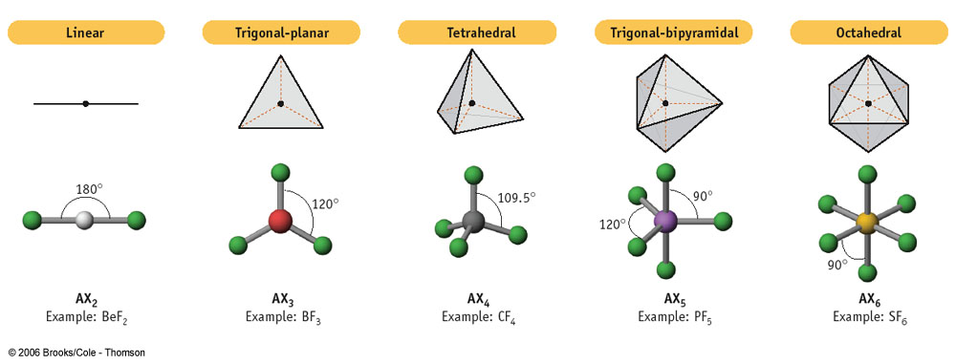

|  |
| --- |
| **9.2 - Intermolecular Forces** (P.203 #13-16, P.208 #23, 24) |

**Intermolecular forces** are attraction forces ______________________________ and are associated with physical changes.

|  |  |
| --- | --- |
|  |  |

1. **Dipole-dipole**

* molecule must be ______________ (molecules with polar covalent bonds are not necessarily polar)
* - side of the molecule is attracted to the + side
* can be intramolecular as well

|  |  |
| --- | --- |
|  |  |
| **Practice**: Which of the following molecules are polar?   1. CH4 2. H2O 3. NH3 | |

How molecules arrange themselves when there are dipole-dipole interactions:

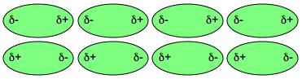

1. **London forces (induced dipoles)**

* all molecules have the ability to develop this intermolecular force
* weak and short-lived attractive force caused by ___________________________________________
  + recall e- distribution is described as a probability
  + at any given point in time, the distribution might be uneven, creating a __________________________________ on the molecule
* increases with increasing #e- and size of molecule

|  |
| --- |
| **Consider This:** Why is chlorine a gas at room temperature, but bromine a liquid? |

1. **Hydrogen bonds**

* molecule contains an H atom bonded to an ____________________________ atom (____, ____, ____)
* the H atom of one molecule is attracted to the F, O, or N on another molecule
* the __________________ of the intermolecular forces
  + H has no e- to get in the way of its attraction to F, O, or N

|  |
| --- |
|  |

|  |
| --- |
| **Practice**: Which of the following molecules can hydrogen bond?  HCN H2O H2S HF |

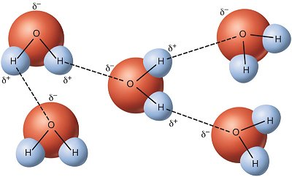 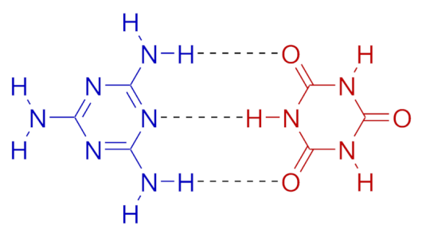

Intermolecular bonds are responsible for how readily covalent substances undergo physical changes

* intermolecular forces must be ______________
* the ___________ intermolecular forces present, and the ______________ that they are, the ____________ the melting and boiling points
* the _____________ the molecule and the higher the _______________, the ___________ b.p

|  |
| --- |
| **Example**: Among H2O, CO2, and H2S, explain why H2O has the highest boiling point at 100°C, followed by H2S at -60.33C, then CO2 at-78.44°C |

|  |
| --- |
| **9.3 – Like Dissolves Like** (P. 207 #18-22, P.208 #25, 27, P. 210 #28-29, P. 212 #30-38) |

How to things dissolve?

* There are three intermolecular forces to consider:

1. attraction between ­­­­­­­­­­­­­­­_________________________________
2. attraction between _________________________________
3. attraction between _________________________________

* The solvent molecule will separate the solute particles by __________________ intermolecular bonds between solute molecules
* The solvent molecules will form strong intermolecular bonds ___________________________

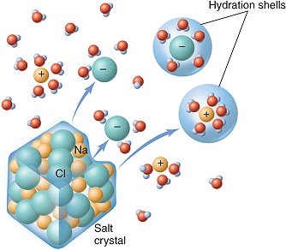 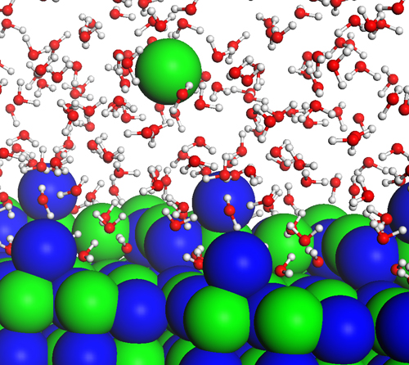

The rule of solubility: “Like Dissolves Like”

|  |  |  |  |
| --- | --- | --- | --- |
| Rule | | What is the Solvent? | What Happens? |
| polar solutes will dissolve best in __________ solvents | | * solvent molecule is very polar * dissolving occurs by ___________________ |  |
| non-polar solutes will dissolve best in ____________ solvents | | * solvent molecule is capable of forming large London forces * dissolving occurs by ___________________ |  |
| ionic solutes will dissolve best in ____________  ____________ | | * dissolving occurs by _________________ forces |  |
| organic solutes will dissolve in __________ solvents | | * solvent molecule is a ___________________   (long chain of C and H)   * dissolving occurs by ___________________ | fat |
| **Example**: Soap dissolves in water and fat dissolves in soap. | | |

|  |
| --- |
| **Example**: Compare the 3 solvents: water, methanol (CH3OH) and ethanol (CH3CH2OH).   1. Which one is the best choice for dissolving a polar solute? 2. Which one is the best choice for dissolving a non-polar solute? Explain using London forces & polarity. Draw a diagram of your molecules to explain your answer. |

Ionic compounds exist as a _____________________________, a very organized arrangement of particles.

|  |
| --- |
| The crystal lattice of table salt, NaCl  http://t0.gstatic.com/images?q=tbn:ANd9GcRrbcx5PHHlnziiTgDG7SyIc6z3TwTIagmhDN192HdRi_uXF6WC2vkkpzHq |

When an ionic solid dissolves in a solvent, we call it a ___________________ reaction. ___________ separate.

|  |  |  |
| --- | --- | --- |
| **Practice**: Write a chemical equation for each of the following ionic compounds to show dissociation.   |  |  | | --- | --- | | 1. AlCl3(s)  ______________________________ 2. FeBr3(g) ______________________________ 3. CH3COOH(l) ___________________________ | 1. HCN(g) _________________________________ 2. Na2SO4(s) _______________________________ 3. Ca(OH)2(s) ______________________________ | |

When covalent compounds dissolve in a solid, molecules separate.

|  |  |
| --- | --- |
| Molecular Solution | Ionic Solution |
|  |  |

|  |
| --- |
| **9.4 - Molarity** (P.98 #59-71, P.212 #30-38) |

**Concentration**: amount of substance in a solution, standard units __________ or ______ called _____________.

* **concentrated** **solutions**: there is ____________ of substance dissolved
* **dilute** solutions: there is _________________ substance dissolved
* **saturated** solutions: the solution has the _________________________ concentration possible
* “the molar concentration of X” can be written as ___________

**Note: the word “solution” includes the substance being dissolved, ________________________

|  |
| --- |
| **Example**: What is the molar concentration of the ions in 0.25M AlCl3(aq)? |

|  |
| --- |
| **Practice**   1. What is the [NaCl] in a solution containing 5.12 g of NaCl in 250.0 mL of solution? 2. Find the concentration of 1.222 g of Na2SO4 in 500.0 mL of solution. 3. Find the mass of NaOH in 3.50 L of a 0.200 M NaOH. 4. What is the molarity of H2SO4 (d = 1.839 g/mL)? 5. How many molecules of MgCl2 are there in a 10.0 mL sample of a 2.50 M solution? 6. Find [Cl-] in a 25.00 mL sample of a 1.0 M CaCl2 solution. |
| **9.5 - Making Solutions** |

**Volumetric flask:** the container used to make solutions

* accuracy ± 0.1%
* comes in set sizes: 10 mL, 25 mL, 50 mL, 100 mL, 250 mL, 500 mL, 1000 mL, 2000 mL

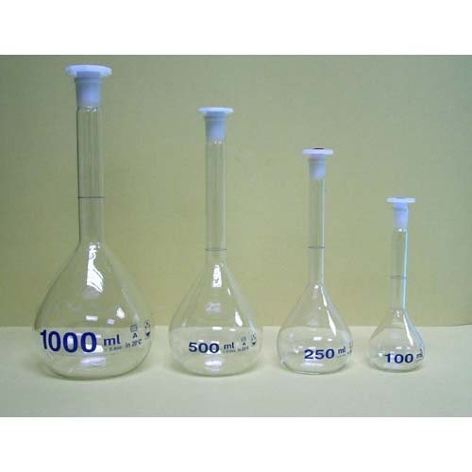

Steps:

1. Know how much of the solution you need to use and choose the appropriate volumetric flask
2. Calculate how much mass you need
3. Weigh the mass on a balance into a **small** beaker
4. Wash the substance into the volumetric using a funnel and a wash bottle
5. Rinse the small beaker 3 times
6. Rinse the funnel well
7. Fill the flask until it is about ½ full with **distilled** water
8. Cap the flask and shake until all the substance has dissolved
9. Using a wash bottle, rinse down the neck of the volumetric flask and add distilled water to the mark (meniscus just touches the mark)
10. Invert the flask repeatedly (about 20x) to evenly mix the solution

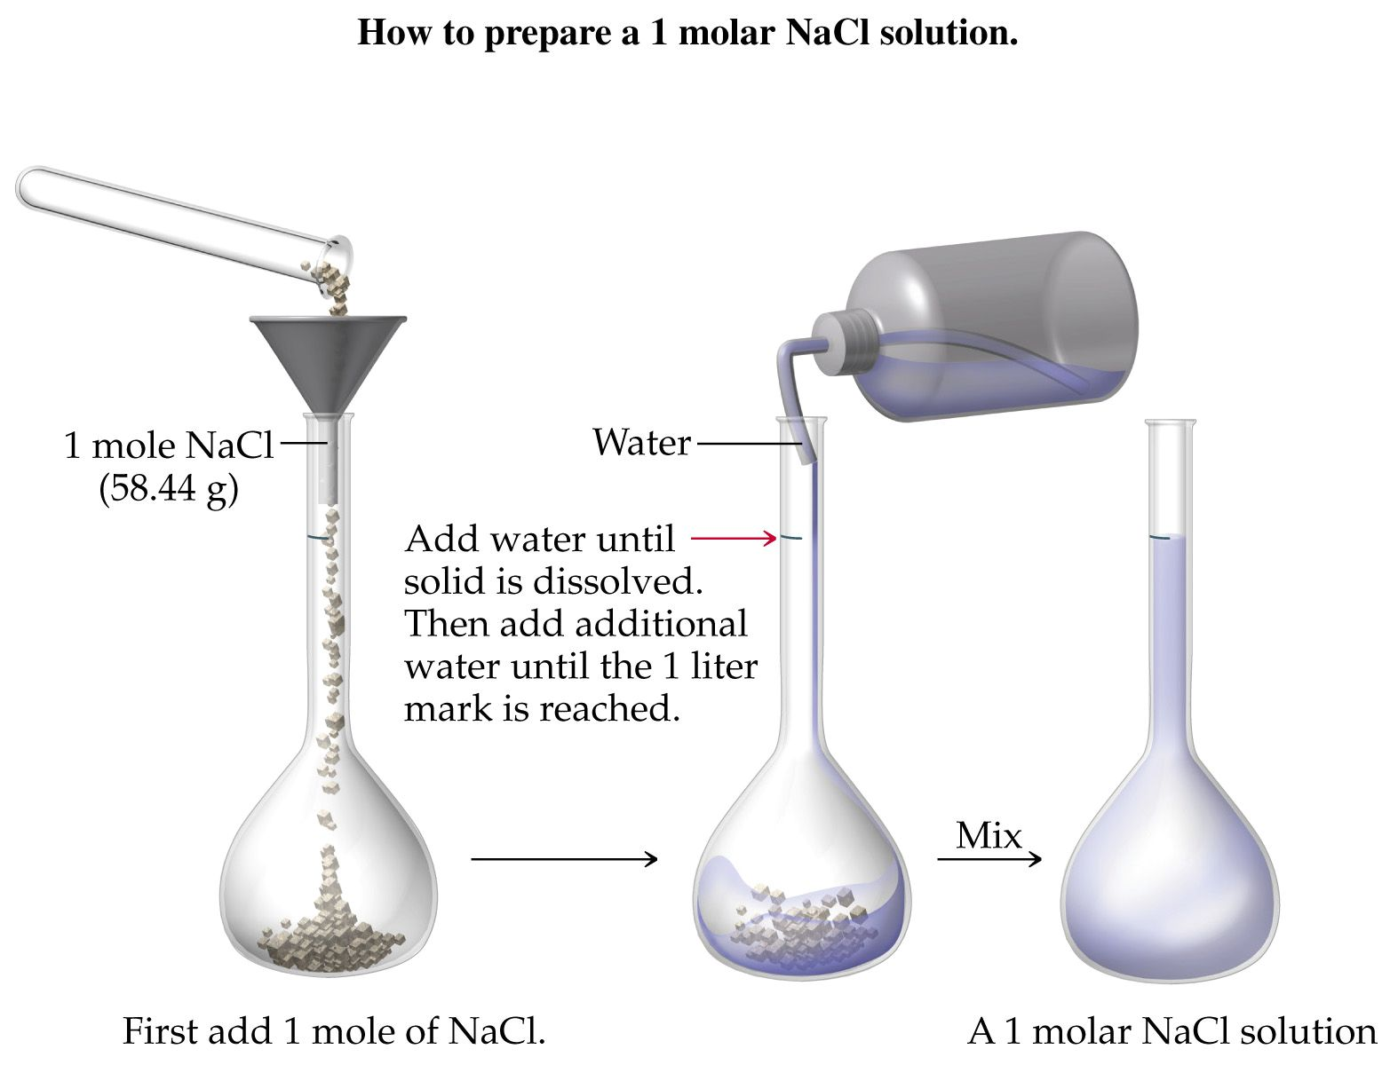

|  |
| --- |
| **Think about this**: What happens to the concentration of your solution if…   1. You didn’t rinse down the beaker: ________________________________________________________ 2. You didn’t rinse down the funnel: ________________________________________________________ 3. You add water past the mark: ___________________________________________________________ |

|  |
| --- |
| **Think about this:**   1. Why do we not add 1.0 L of water first, and then dissolve our solute?   ____________________________________________________________________________________   1. What should you do if you add water passed the mark? _______________________________________ 2. What happens if your solution is not properly mixed? _________________________________________ |

|  |
| --- |
| **9.6 - Dilutions** (P.102 #78-86, 89) |

**Dilution:** ______________________________________________________

* not all chemicals are solid when you buy them
  + some chemicals are sold as ______________________________________ (eg. HCl sold in 12 M)
  + you must perform dilutions to make solutions for experiments

|  |
| --- |
| **Example:** If we start with a 1.0 L solution of 1.2 M NaCl (salt water), and we add 0.5 L of water to it, what is the final concentration of NaCl?      **Solve Using Moles:** |

Before and after a dilution, ________________________ is constant. We have two equations with something in common, so we can set up the following:

|  |
| --- |
| **Solve Using Equation:** |

|  |
| --- |
| **Practice**   1. If 200.0 mL of 0.500 M NaCl is added to 300.0 mL of water, what is the resulting [NaCl] in the mixture? 2. If 500.0 mL of 0.1 M CH3COOH is added to 200.0 mL of water, what is the resulting [CH3COOH] in the mixture? 3. A student mixes 100.0 mL of water with 25.0 mL of sodium chloride solution having an unknown concentration. The molarity of the diluted sodium chloride solution is 0.0876 M, what is the molarity of the original sodium chloride solution? 4. How much 12 M HCl is required to make a 1.00 L solution of 2.00 M HCl? |

|  |
| --- |
| **9.7 - Mixing Solutions** (P.102 #88, 90) |

|  |
| --- |
| **Example**: What is the concentration of each type of ion in a solution made by mixing 50.0 mL of 0.240 M AlBr3 and 25.0 mL of 0.300 M CaBr2?  **Example**: 125 mL of 0.100 M NaCl is mixed with 270 mL of 1.20 M Na2SO4. Find the final concentration of each ion.  **Example:** 75 mL of 0.500 M Ca(NO3)2 is added to 85 mL of 0.600 M NaCl. Find the final concentration of each ion. |

Review Questions P.103 #95-102

|  |
| --- |
| **9.8 - Concentration and Stoichiometry** (P. 131 #17-24) |

|  |
| --- |
| **Practice**:   1. How many grams of copper will react to completely replace silver from 208 mL of 0.100 M solution of silver nitrate? 2. If 17.5 g of zinc are reacted with phosphoric acid, H3PO4, then zinc phosphate and hydrogen are produced. If the phosphoric acid is a 3.00 M solution, how many litres of the solution are needed to completely react with the zinc? 3. What volume of 1.50 M silver nitrate is required to produce 15.0 g of silver when it reacts with copper? The reaction also produces copper (ll) nitrate. 4. A 10.0 mL sample of a saturated solution of calcium hydroxide is needed to neutralize 23.5 mL of 0.0156 M hydrochloric acid. 5. What is the molarity of the calcium hydroxide in the saturated solution? 6. What mass of the calcium hydroxide is dissolved in 250.0 mL of saturated calcium hydroxide? 7. 500.0 mL of a 0.100 M HCl solution is mixed with 250.0 mL of a 0.150 M NaOH solution. 8. What is the limiting reagent? 9. What is the concentration of NaCl in the final mixture? |

|  |
| --- |
| **9.9 – Solubility** |

**Solubility**: The ________________ amount of __________ that can be ______________ in a given amount of solvent at a given temperature. Something is soluble if it can achieve 0.1 M or more at 25°C.

|  |  |  |  |  |  |  |  |  |  |  |  |  |  |  |  |  |  |  |  |  |
| --- | --- | --- | --- | --- | --- | --- | --- | --- | --- | --- | --- | --- | --- | --- | --- | --- | --- | --- | --- | --- |
| **Practice**: Use the Solubility Table in the Data Booklet to predict if the following compounds have high solubility or low solubility in water.   |  |  |  |  | | --- | --- | --- | --- | | Compound | Solubility | Compound | Solubility | | PbI2 |  | MgSO4 |  | | Sr3(PO4)2 |  | Ba(OH)2 |  | | *CuCl2 |  | CuCO3 |  | | *CuCl |  | Ag2S |  | |

**Precipitate**: an insoluble compound, often formed from a chemical reaction. These chemical reactions can be represented in three ways:

* **Formula equation**: a complete, balanced chemical equation
* **Complete ionic equation**: shows all soluble ionic species broken up into their respective ions
* **Net ionic equation**: shows only the species which are actively involved in the reaction, removes spectator ions

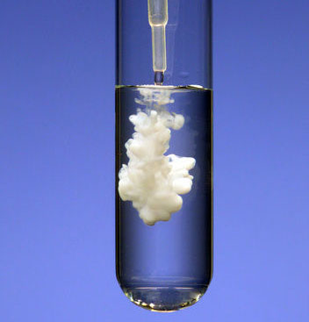

|  |  |
| --- | --- |
| **Example: AgNO3 mixed with Na2CO3** | |
| Type of Equation | Equation |
| Formula |  |
| Complete ionic |  |
| Net ionic |  |

|  |  |  |  |  |  |  |  |  |  |  |  |  |
| --- | --- | --- | --- | --- | --- | --- | --- | --- | --- | --- | --- | --- |
| **Practice**: For the following mixtures, write the formula, complete ionic, and net ionic equations.   1. MgS and Sr(OH)2  |  |  | | --- | --- | | Complete formula |  | | Complete ionic |  | | Net ionic |  |  1. CuBr2 and Pb(NO­3)2  |  |  | | --- | --- | | Complete formula |  | | Complete ionic |  | | Net ionic |  | |
| **9.10 – Calculations with Solubility** | |

|  |
| --- |
| **Practice:**   1. Find the final ion concentration when 55.0 mL of 2.0 M NaOH is reacted with 75.0 mL of 3.0 M Ca(NO3)2. 2. Find the final ion concentration when 150.0 mL of 1.2 M MgI2 is reacted with 50.0 mL of 2.5 M LiOH. |

|  |
| --- |
| **9.11 - Conductivity** (P.198 #6-8) |

**Conductivity**: the ability of a substance to conduct electricity, or to allow the flow of __________________. Substances that allow the flow of charge are conductive.

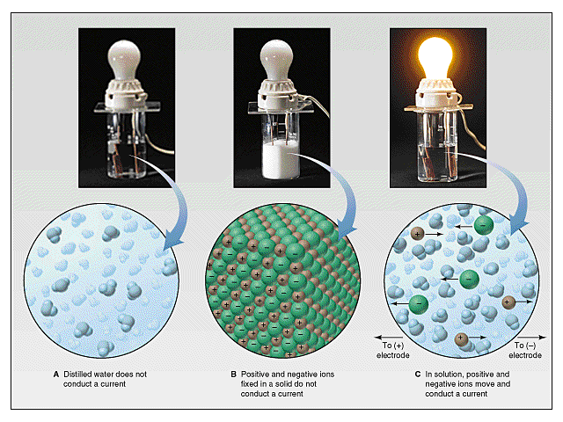

In order to allow the flow of electrons, a substance must contain __________. The more ions a substance has, the ________________ the conductivity.

|  |  |
| --- | --- |
| Conductive Substances | Non-conductive Substances |
|  |  |
|  |  |
|  |  |
|  |  |
|  |  |

|  |  |  |  |  |  |  |  |  |  |  |
| --- | --- | --- | --- | --- | --- | --- | --- | --- | --- | --- |
| **Practice**: Circle the more conductive substance.   |  |  | | --- | --- | | 1. 2 M NaCl | 0.5 M NaCl | | 1. Fe(s) | 0.5 M CaCl2 | | 1. CH3OH(l) | CH3OH(aq) | | 1. NaOH(aq) | CH3COOH(l) | | 1. 2 M LiCl | 2 M MgCl2 | |