Chapter 1
1.1

Observing Living Things
P. 11-21 BC Science 8

Vocabulary & Concepts

unicellular multicellular compound microscope magnification power resolving power

Examining Very Small Living Things

Brainstorm: Why are we interested in seeing very small things? What do we need to see very small things?

The is used by scientists to observe small unicellular and multicellular things.
• There are many different types:
o Magnifying glass
o Compound light microscope
o Transmission electron microscope (TEM)
o Scanning electron microscope (SEM)
• Early microscopes were built in the late 1600s and early 1700s
• was one of the first people to build a microscope
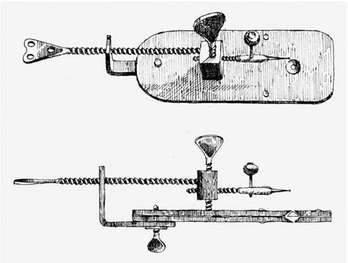o Could magnify up to and used it to observe microscopic living things

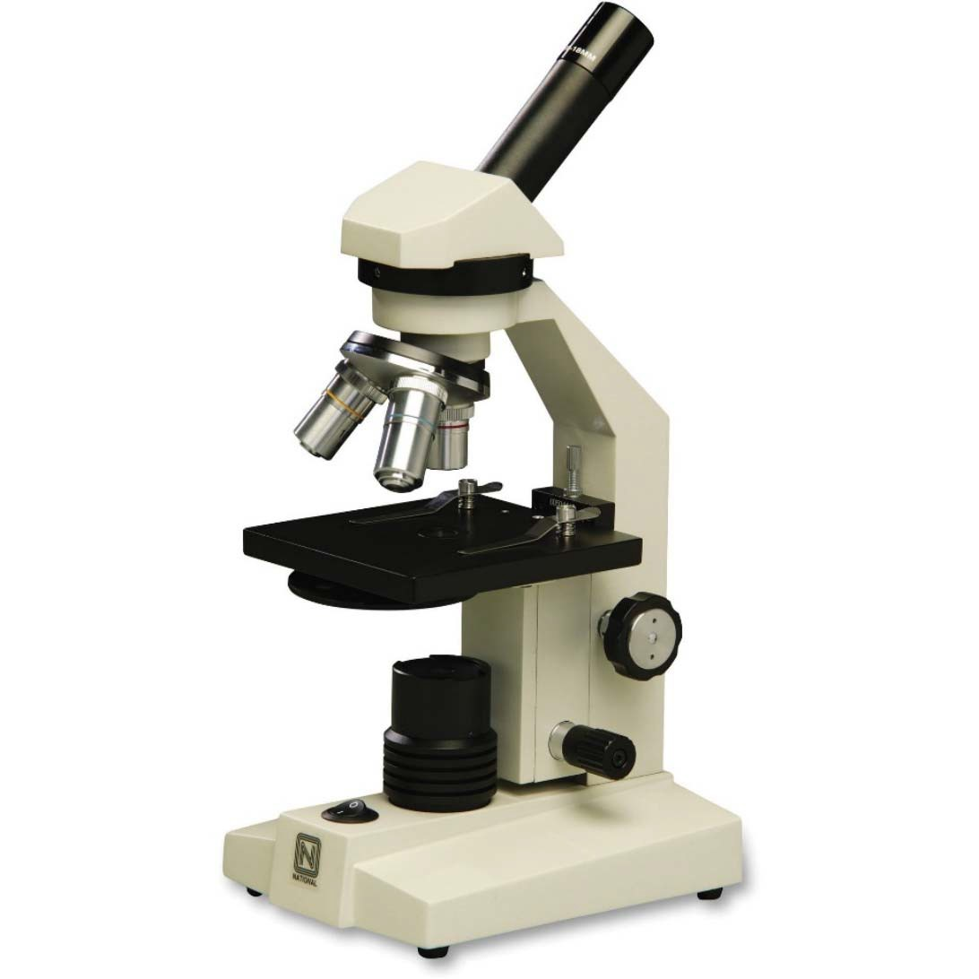

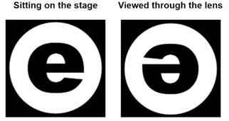The compound light microscope has sets of lenses that magnify an image. The image you observe is ,
, and .

Each objective lens has a different magnification power:

Total magnification power =

Power | Objective Lens  Magnification | Eyepiece Lens  Magnification | Total Magnification Power
Low
Medium
High

Most people can see only dots separated by 0.1 mm or more in the diagram below. This means that most people can see the individual dots in diagrams A, B and C, but do not have the resolving power to see the dots in diagram D.

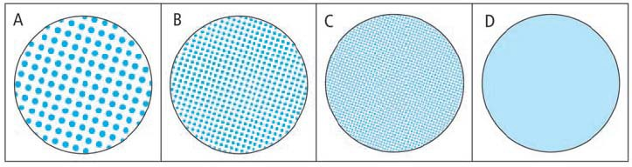

Resolving power:
• The microscope extends human vision by enabling us to view objects that are
and together.
• The compound light microscope has a resolving power of .
A micron or micrometre is .

