Chapter 1  1.3 | Types of Cells & Their Parts  P. 24-37
Vocabulary & Concepts
prokaryotic eukaryotic bacteria organelle
nucleus cytoplasm endoplasmic reticulum ribosome Golgi bodies vesicles vacuoles lysosome chloroplast cell wall photosynthesis cellular respiration

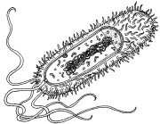
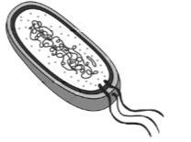
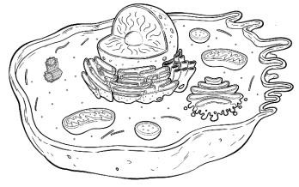
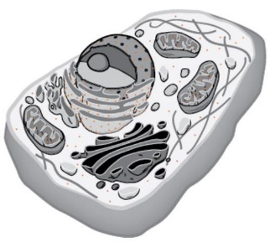
Types of Cells

Cells

Prokaryotic

These are
cells that don’t have many
(internal structures). They lack a
Eukaryotic

These are cells that have many (internal structures), including a .

Bacteria Archaea Protists Fungi Animal Plant

Animal and Plant Cells

Animal Plant

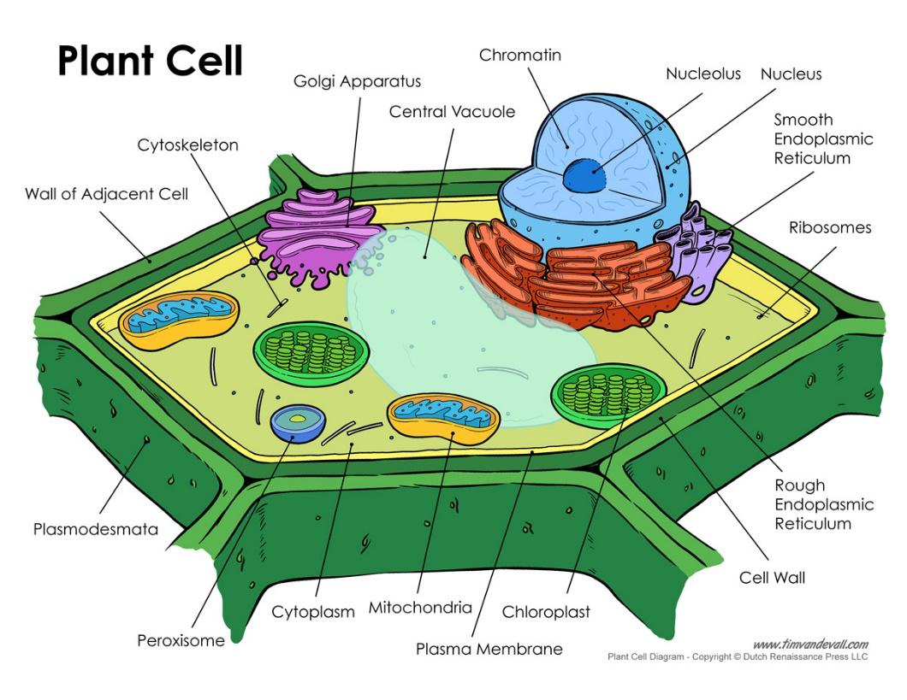
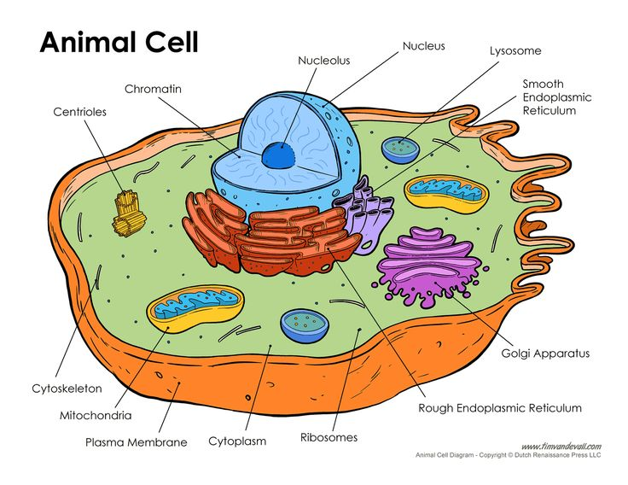

The BIG Summary
Part / Organelle | Function | Animal | Plant
nucleus | Holds __________, controls cell function.
endoplasmic reticulum | Place for ____________ and _____________ synthesis (creation).
ribosome | Manufactures ____________________.
Golgi bodies | ______________ proteins for transport.
vesicle | Transports materials in the ___________ around (nutrients, proteins, etc.)
Vacuole | - Holds cell material like _______________.  - Very large in ______________.
lysosome | Breaks down “stuff” within the cell.
mitochondria | Carries out _, a chemical reaction that gives the cell energy:
chloroplast | Carries out _, a chemical reaction that uses to make sugar.
cytoplasm | Jelly fluid that gives cell ________________.
cell membrane | Controls what goes ________ and _________ of the cell.  Holds the cell together.
cell wall | Very rigid material that gives plants _____________ and _________.

