Chapter 1  1.4 | Micro-organisms  P. 38-45
Vocabulary & Concepts
Micro-organsim |  | microbe | bacteria | pathogen
red tide
What are some positive and negative ways that we interact with microbes?
What are Micro-organisms?

A micro-organism, or microbe for short, is simply an organism that is really small. Two examples are _________________ and ____________________________
Microbes are our friends! ☺
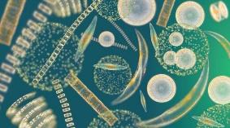
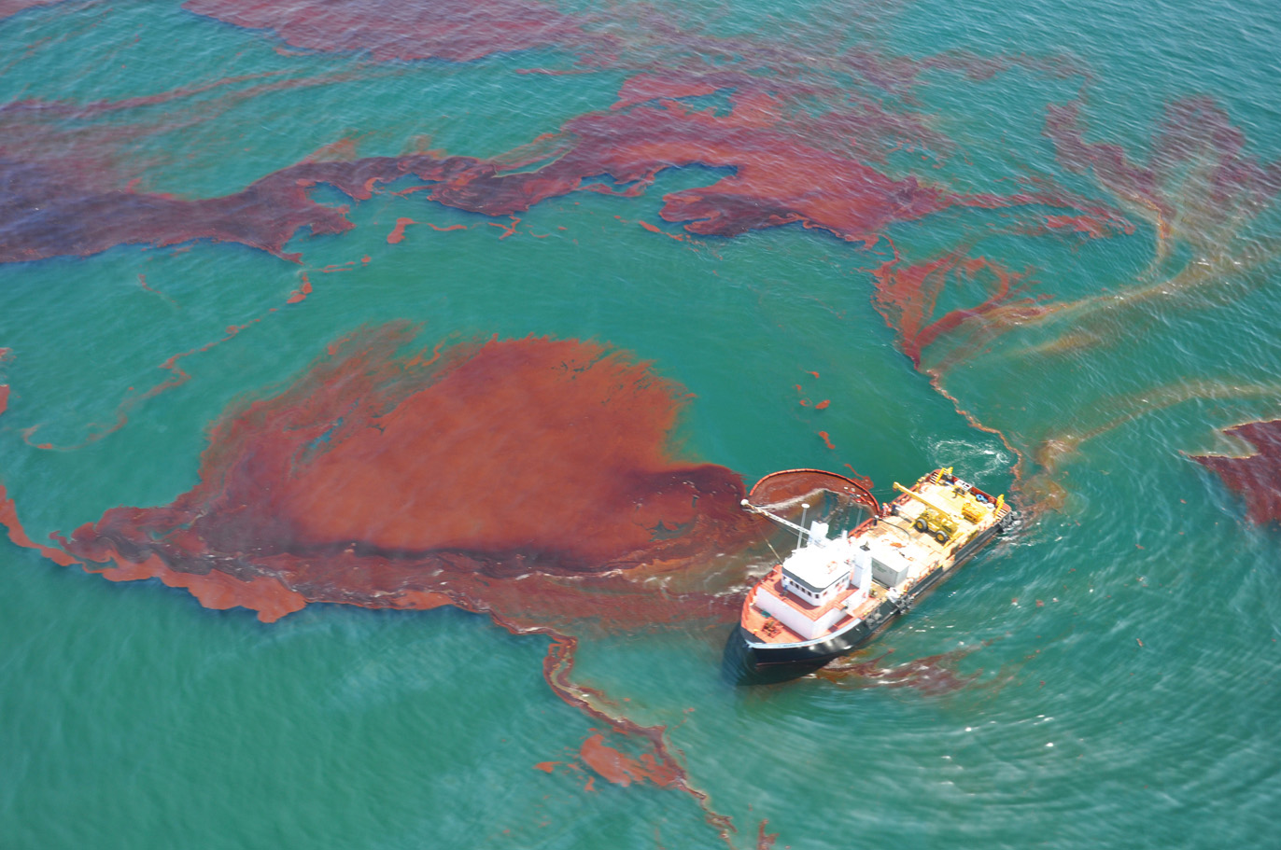
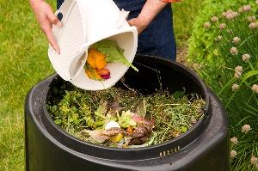
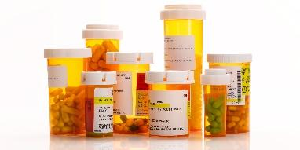
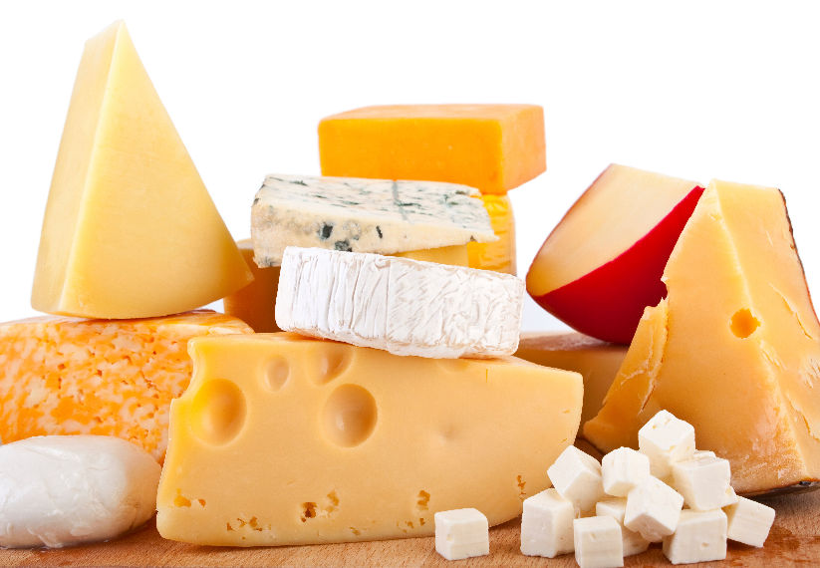
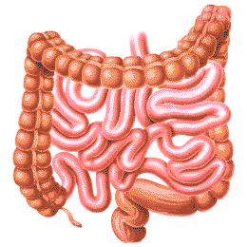

Microbes are not our friends ☹
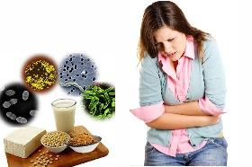
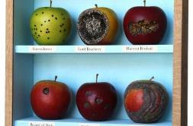
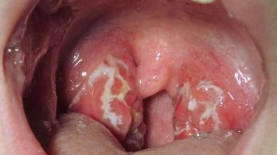 | ______________________ are microbes that are harmful to people. Streptococcus bacteria is an example. It causes strep throat. Other examples include __________________, ________________, ___________________.
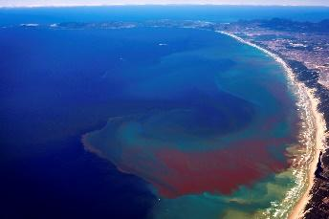 | When phytoplankton in the ocean grow out of control, it causes ____________________________. The phytoplankton produce _________________ (harmful chemicals) that end up in shellfish. Eating the shellfish during this time will result in serious _______________________________.

*Meet the Microbes that are found all around your body: https://www.ted.com/talks/jonathan_eisen_meet_your_microbes
Activity
- Go to the following website: https://goo.gl/4fBDQ2
- Scroll down and click “start exploring”
- Explore the microbes under the microscope and pick one that interests you. Complete the table below.
- Share with another person in the class
Name | Drawing | Main address (where it is found) | Occupation (what it does)

