4.3: Evolution

A Timeline of Evolutionary Thought

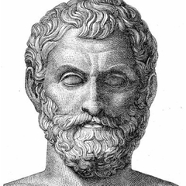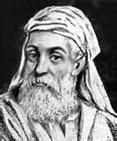
Empedocles (5th century BC)
Heads, limbs, and other organs are joined at __________ and only some combos are fit _____________________!
Anaximander (6th century BC)
Species are __________________. We’re all descended from ___________!
______________ (384-322 BC)
A deity created templates, from which we are all created.
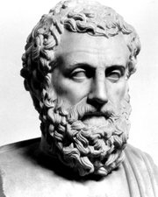
Christianity (1800s)
God created all living things. Living things are unchanging because God’s ___________ ____ ____________.

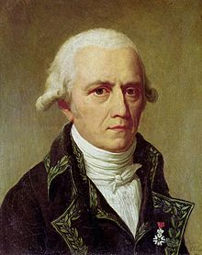
Lamarck (1744-1829)
Giraffe’s long necks developed because ______ ______ ______________. If an ______________ changes during life in order to adapt those changes are passed on to its offspring. IfIf an organism changes during life in order to adapt to its environment, those changes are passed on to its offspring.

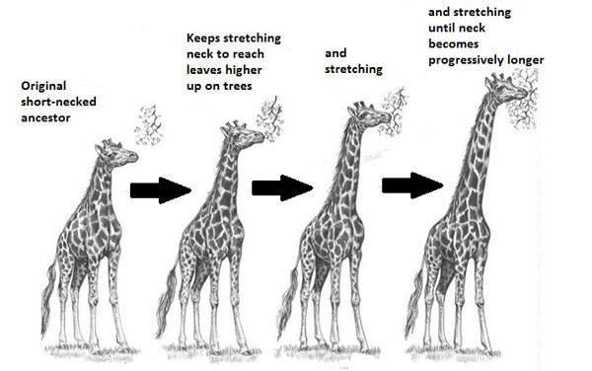

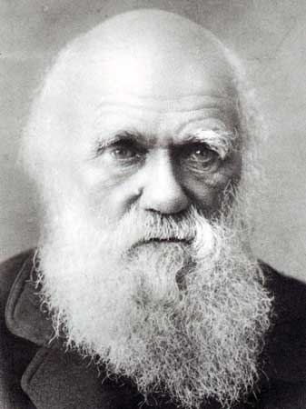
Gregor ______________ (1856)
____________ are how phenotypes are passed from one __________ to the _______.

Darwin (1859)
All species, living and extinct, have descended without interruption from one or a few __________________forms of life. Differences in the survival and reproduction of _________________, leading to differences in their contribution to the next __________________, result in a change of frequency of heritable phenotypic variations in _________________ over time. I am not really sure HOW all this happens though.

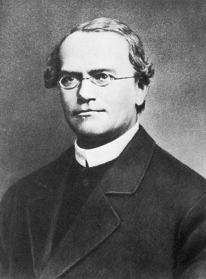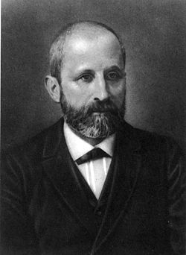
Miescher (1869)
I tried to isolate ____________, but instead I found _________.

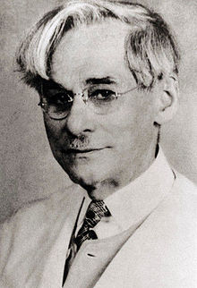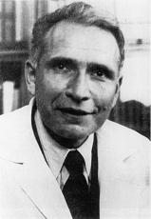
Chargaff (1950)
DNA sequence _________ among species, but A always pairs with T, and G with C.

Levene (1929)
DNA is made up of a ______________ group, deoxyribose sugar, and nitrogenous ________.

Watson & Crick (1953)
We have discovered ______’s 3D structure

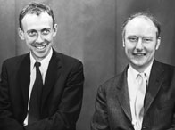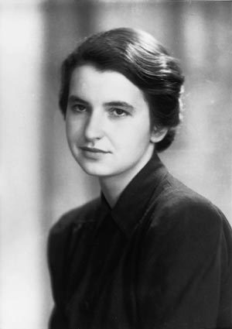
Rosalin Franklin (1953)
Actually, it was me who discovered the _________________________________.

Natural Selection

Darwin was influenced by his observations of _____________ _________________ selection and ________________ __________________.

Think: What is artificial selection and selective breeding? Where/why would this be used? Give some examples.

He then travelled to the ______________________ _______________________ and observed populations of birds (he called them finches). It was there that he developed the idea of ______________ _________________.

Watch: https://www.youtube.com/watch?v=s64Y8sVYfFY

Summarize: What were Darwin’s observation at the Galapagos?

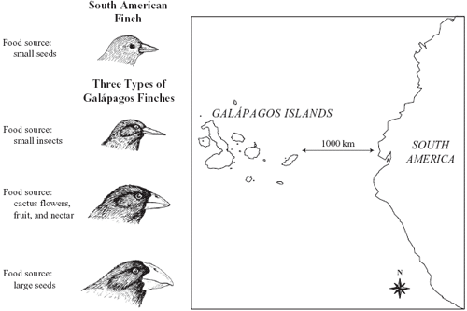

Natural selection is a mechanism that can be broken down into four steps:

- There is ____________ __________________ in a population.

- Overproduction of offspring leads to _________________ for ______________________.

- Individuals with _________________ _____________________ most likely to survives to sexual maturity to pass on their genes.

- The _______________ of those individuals that survive and ________________ will become more common in a population.

Natural Selection Examples: In the following flow diagrams, explain what is happening.

In artificial selection, _____________ are doing the selecting whereas in natural selection, it is ______________.

Evidence for Evolution

- descent with modification (a change in population allele frequency)

Evidence to support evolution in addition to real-time direct observations of the world:

 | Expected Observations If
Evidence | If Evolution is True | If Evolution is False
- The Fossil Record The entire collection of fossils we have
- Geographical Patterns in the Fossil Record
- Transitional Forms
Intermediate forms between fossil and more current day organism
- Developmental Homologies Similarities in how offspring develop
- Structural Homologies Similarities in structure among organisms
- Vestigial Structures Structures that have no apparent function
- DNA Records
Questions:

- Does Natural Selection support Evolution? Explain.

- How are Darwin’s finches a good example of natural selection?

- How has our understanding of evolution changed over time?

- Does it take long for adaptations (evolution) to occur? Explain.

- Humans, whales, birds and lizards all have similar arm bones. What is this phenomenon called and what does it signify?

