4.4 Inheritance – Basic Mendelian Genetics

Basic Vocabulary

Proteins determine many ______________ in an organism, and proteins are created from __________. Parts of DNA that code for proteins are called ___________________.
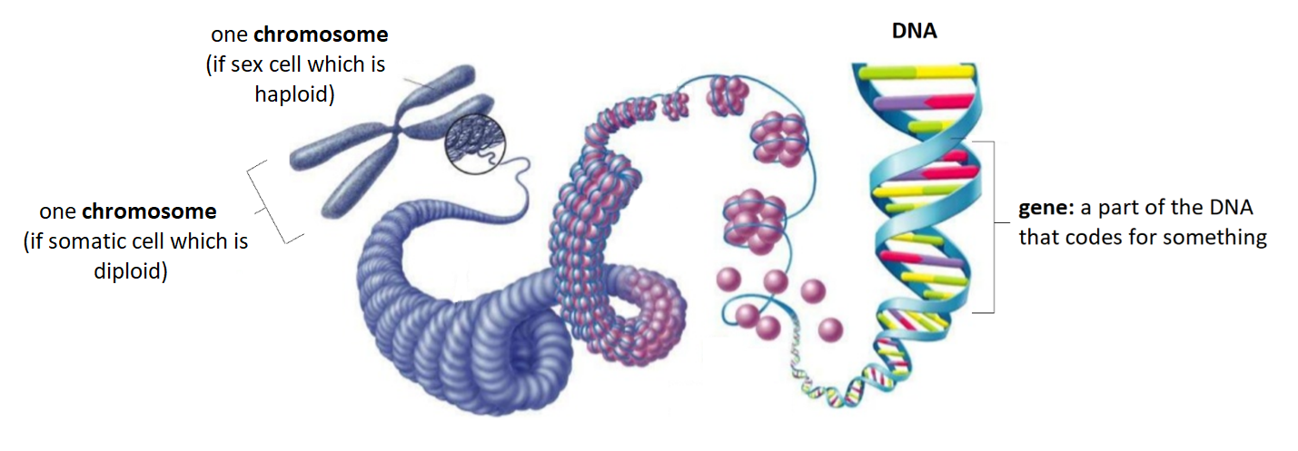

Humans have _____ pairs of chromosomes. The 23rd pair is the XX for __________ and XY for __________. | Any gene can have multiple versions, called _______.
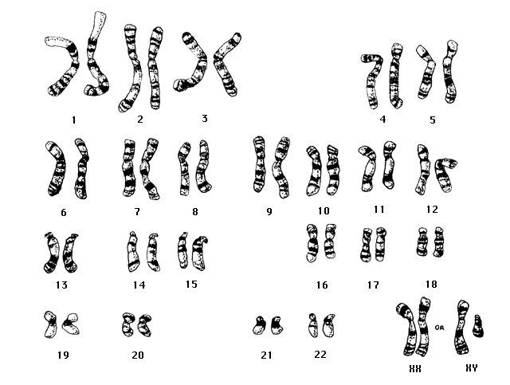

Homozygous | Heterozygous
If a homologous pair of chromosomes carries two copies of the ______________ ________________. | If a homologous pair of chromosomes carries two ________________ _______________.

- Who is known of the “Father of Genetics?” _________________________________________
- How did he contribute to genetics? Write down a few points you learned in the video!

Phenotype vs. Genotype

Phenotype:  The _______________ and _____________________ traits of an organism (__________________ _________________) | 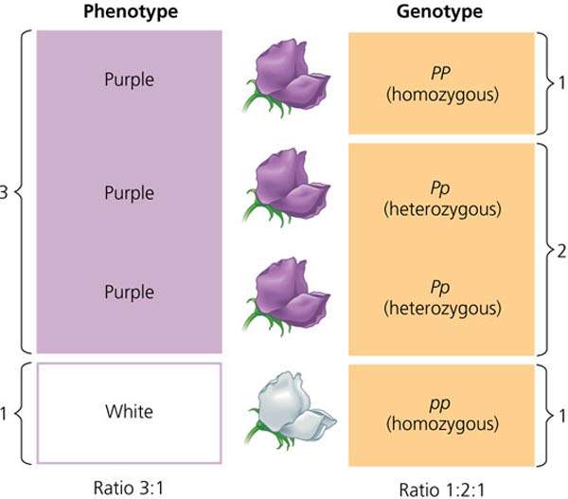 | Genotype:  The set of ____________ of an organism

For each genotype below, indicate whether it is heterozygous or homozygous.

AA | Ee | Gg | Mm
Bb | ff | Jj | nn

Think of four different examples of phenotypes that you possess
1.
2.
3.
4.
Dominant and Recessive Genes

Dominant allele:  An allele that is ________ _____________ in the phenotype of a heterozygote. The symbol is a ____________ letter.  Recessive allele:  An allele whose phenotypic effect is ____ observed in heterozygotes. The symbol is a ________ letter. | 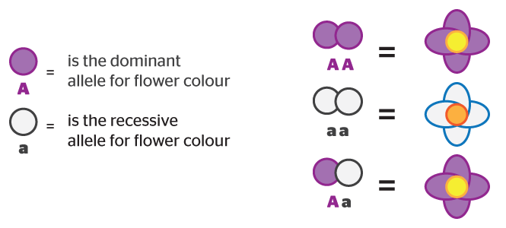

Think About It This Way: You have a tube of black and yellow paint, representing two alleles for colour. You mix the two paints together. Even though the yellow paint is present, the black completely masks the yellow paint, making the mixture appear overall black.

- For each of the genotypes below determine what phenotypes would be present.

- Purple flowers are dominant to white flowers.  PP _________________________  Pp _________________________  pp _________________________ | - Brown eyes are dominant to blue eyes.  BB _________________________  Bb _________________________  bb _________________________

- For each phenotype below, list the possible genotype(s).

- Straight hair is dominant to curly.  straight _________________________  curly _________________________ | - Oval heads are dominant to square heads.  pointed _________________________  rounded _________________________

A punnet square is a diagram that helps us predict the outcome of a particular breeding with two “parents”. It visualizes the probably of having an offspring with particular traits.

MONOHYBRID CROSS= ___________________________________________________________________
Parent 2 allele 1 Parent 2 allele 2  Parent 1 allele 1 possible gamete possible gamete  Parent 1 allele 2 possible gamete possible gamete | 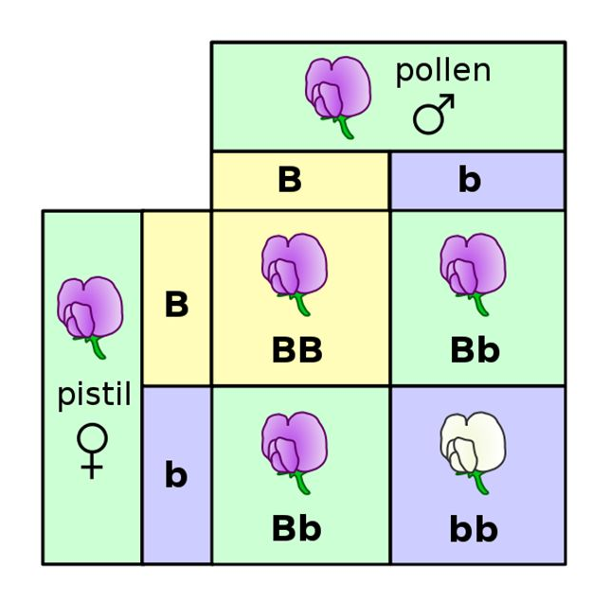
- Set up the Punnet squares for each of the crosses listed below.

- Round seeds are dominant to wrinkled seeds. Use R for the round seed allele, and r for the wrinkled seed allele. The parents are Rr and rr.

 | r | r
R
r

What percentage of the offspring will be round?

- A homozygous round seed plant is crossed with a homozygous wrinkled seed plant.

What percentage of the offspring will be homozygous RR? _____________________

- Tall trees are dominant to short trees. A Tt plant is crossed with a Tt plant.

What percentage of the offspring will be short? _____________________
Incomplete Dominance

Incomplete dominance is a situation in which the phenotype of heterozygotes is an ________________ (_______) between the dominant and recessive phenotypes.

For example (explain what is happening in the picture to the right)

Think About It This Way: You have a tube of black and white paint, representing two alleles for colour. You mix the two paints together. Both paints are present, but the overall mixture is grey. Grey is an intermediate colour between the two original alleles, black and white.

Black Paint | Mixed Colour | White Paint

- In Japanese four o'clock plants, red (R) colour is incompletely dominant over white (r) colour, and the heterozygous condition (Rr) results in plants with pink flowers. For each of the following crosses, construct a Punnett square and give phenotypic and genotype ratios of the offspring.

 | - A red plant and a white plant | - A red plant and a pink plant
 | - A white plant and a pink plant | - Two pink plants
Codominance

Codominance is a is a form of dominance wherein ___________ ____________ of a heterozygote are _______________ expressed. This results in offspring with a phenotype that is ______________ dominant nor recessive.

For example (explain what is happening in the picture to the right.)

.

Think About It This Way: You have a tube of black and white paint, representing two alleles for colour. You mix the two paints together, but they act like oil and water. Both paints are present and both alleles are fully expressed.

- Two homozygous flowers are crossed with one another. One flower is yellow (YY) and the other is black (BB). These two colours, when crossed, result in codominant expression. Draw a Punnett square for the cross of these two plants and list the colour(s) or all offspring.

- A cross between a black cat (BB) and a tan cat (TT) produces a tabby pattern (black & tan fur together).

- What pattern of inheritance does this illustrate?

- What percent of kittens would have tan fur if a tabby cat is crossed with a black cat?

Sex-Linked Inheritance

Sex-linked inheritance is when a gene is carried on the sex chromosomes, _____ and _____. This means that certain traits are passed down from the ___________ (______) and others from the ____________ (____).

For example, a dominant mutation occurs on a gene that is only carried by the X chromosome. Each child of a mother affected with an X-linked dominant trait has a _______% chance of inheriting the mutation. If only the father is affected, _____% of the daughters will be affected, since they inherit their father's X-chromosome, and ___% of the sons will be affected, since they inherit their father's Y-chromosome

Examples of Sex-Linked Traits:

- In humans, one of the genes determining color vision is located on the X chromosome. The dominant form (C) produces normal color vision; red-green color blindness (c) is recessive. If a man with normal color vision marries a color-blind woman, what is the probability of their having a color-blind son? A color-blind daughter?

- In the couple described in the last problem, the woman gives birth to a color-blind but otherwise normal daughter. The husband sues for a divorce on the grounds of adultery. Will his case stand up in court? Explain.

