4.5 Genetic Engineering

What is genetic engineering?
Genetic engineering is the direct____________________ of an ___________________’s _______________, which is the list of specific traits (genes) stored in the DNA.

Changing the genome enables engineers to give desirable _______________________ to different organisms.

Organisms created by genetic engineering are called _________________ __________________ ___________________________(GMO’s)

What is the GMO process?

All genetic changes ____________________________________________________________ of the organism.

By changing which proteins are produced, genetic engineers _________________________________________
__________________________________________________________________________________________.

Genetic modification can be completed by a number of different methods:

- Inserting new ________________________________________ randomly or in targeted locations
- Direct replacement of ______________ (________________________________)
- _______________________ of genes
- __________________ of existing genes
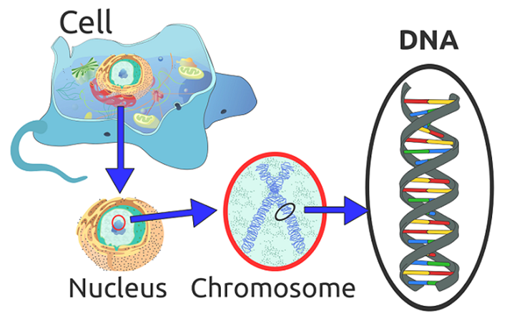

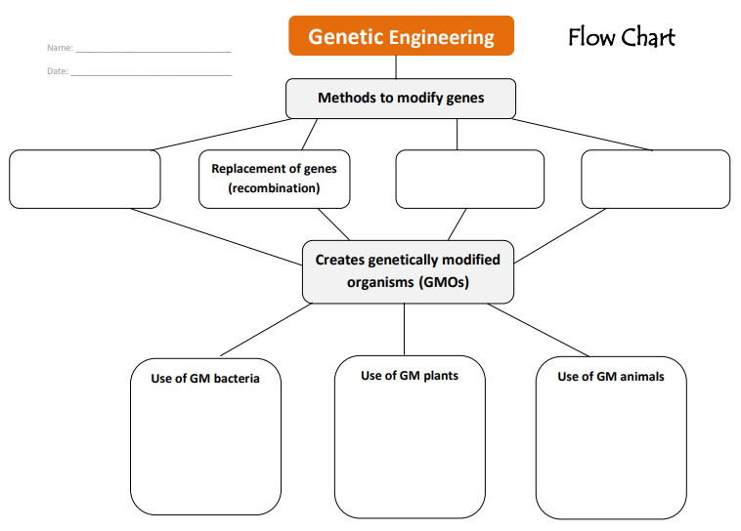

Table 1: Main Genetically Modified Crops in Canada
Crop Type
% that is Genetically Modified in Canada

