A Little Stoichiometry Fun With Magnesium…
Name:__________________
You and your partner are going to experimentally determine the stoichiometry of a chemical system. Please read the procedure carefully, wear safety goggles, and tie back any long hair.
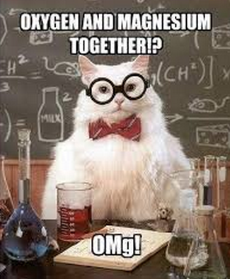
Materials
- Bunsen burner
- Lighter
- Tongs
- Electronic balance
- 1 strip of magnesium ribbon
Procedure
- Weigh the strip of magnesium ribbon and record its mass
- Using the tongs, light the strip of magnesium ribbon on fire. ** Do not look directly at the light!
- Write down your observations

Questions
- The mass of our magnesium ribbon was ___________

- Describe what happened when you burned the magnesium: ____________
_____________________________________________________________
_____________________________________________________________
_____________________________________________________________

- Write out a balanced equation for the reaction that took place.

- Find the number of moles for each product and reactant (there should be 3 in total).

- Find the grams for each product and reactant.

- Find the litres of oxygen that were needed for this reaction to occur.

