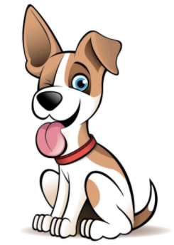
A Recipe for Traits

Vocab
DNA | gene | amino acid | chromosome
genotype | phenotype | heritable traits

Purpose:
In groups, you will decode various “DNA Recipes” for man’s best friend to observe how variations in DNA lead to the inheritance of different traits. Letters on paper (representing the various bases of DNA) are randomly selected and used to assemble a DNA molecule. This DNA molecule will then be read as a “gene,” and a protein will be built expressing that specific genetic variation. Your group will then get together to draw a picture of your dog!

Activity Instructions
- In partners, collect an envelope of DNA pieces. (You will be creating a dog with 2 other groups).
- Between the 3 pairs of partners, each pair needs to choose three traits from the trait envelope (there are nine in total). These will be the traits you and your partner are responsible for.
- Write your 3 traits on your DNA/Amino Acid Worksheet.
- With your partner, randomly choose 6 letters (one at a time) out of your envelope and write them IN ORDER on your first DNA chain. These represent a strand of DNA.
- Read your DNA strand in groups of 3, and using the chart below find the matching symbol for each group. These symbols represent your amino acids. Draw your amino acid underneath your DNA pieces.
- Once written down, put all of the DNA pieces back in the envelope.
- Complete steps 4-6 for your other two traits.
- Match your amino acid with the phenotype, and add it to the picture!
- With all 3 groups, cut out your DNA chains and tape them in the following order:
Body type, head shape, ears, legs, eyes, tail, coat colour, hair, eyebrows.
Tape your chain to your picture. This is the entire DNA chain for your dog!
- Take a look at the other dogs created in your class, and answer all discussion questions.

DISCUSSION QUESTIONS:
- What do we mean when we say “traits are heritable characteristics?” Give an example.

- Do all of the dogs look the same? Why or why not? Explain.

- What are some traits that YOU have inherited from your parents?

- What is the difference between a chromosome, DNA, and a gene?

- What are amino acids, what is their purpose, and how are they made?

- What is the difference between phenotype and genotype? Give examples.

Key for Amino Acids
 | SECOND BASE
FIRST BASE |  | A | T | G | C | A  T  G  C  A  T  G  C  A  T  G  C  A  T  G  C | THIRD BASE
 | A
 | T
 | G
 | C

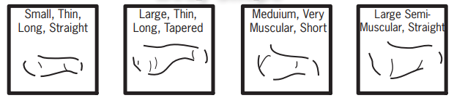
BODY TYPE

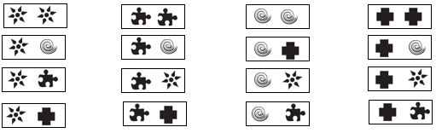

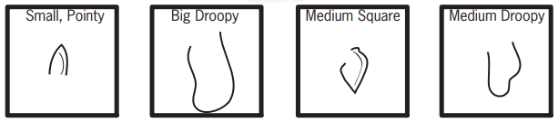
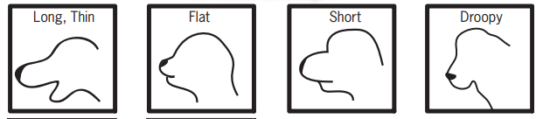
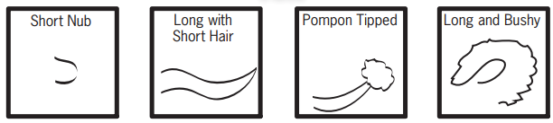
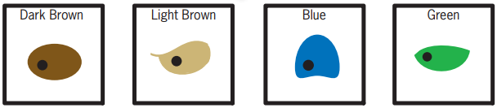
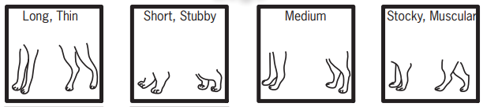
EARS
HEAD SHAPE
TAIL
EYES
LEGS
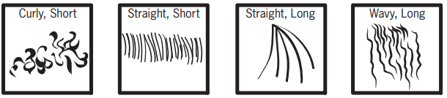
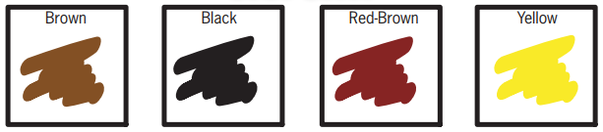
Sexy, thin
Exotic,natural
Mysterious, thick
Dramatic, thin
EYEBROWS
HAIR
COAT COLOUR

