Chemistry 11: ACTIVITY
Exploring Different Types of Matter
Name: _______________________
Date: _______________________
INTRODUCTION: Matter encompasses everything around us. Matter can be further separated depending on the characteristics of the substance. Pure Substances include things such as: all the elements of the periodic table or pure collections of a single molecule (i.e. – pure water (H2O)). Mixtures include any combination of two or more pure substances (i.e. – salt (NaCl) and water (H2O)). Each can be further divided as shown in the chart below.
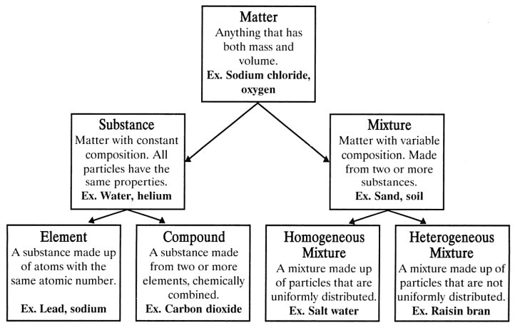

Purpose: _____________________________________________________________________________
__________________________________________________________________________________________________________________________________________________________________________

Materials:

Pass around the items that Ms. Dow give you, and fill in the chart below.
ITEM | CLASSIFICATION OF MATTER (pure substance or mixture) | Element/Compound?  Hetero/Homogenous Mixture? | IF it is a mixture, devise a separation strategy.

