Unit 6
Energy

6.0 – Forms of Energy

Form of Energy | What is it? | Where does it come from? | Where is it used?

6.1 – Energy Transformations

- Go to PHET – Energy Forms and Changes
- State the energy transformations taking place in each situation given.

Turbine moved by medium water flow from faucet with a water heater system  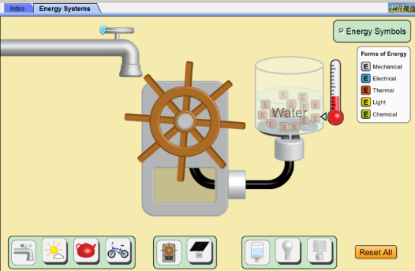 | Solar panel in medium cloud cover with a regular light bulb system  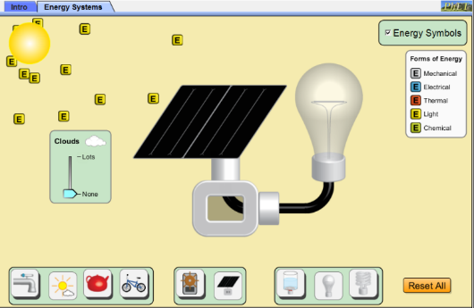
Turbine moved by steam from medium heat kettle with a water heater system  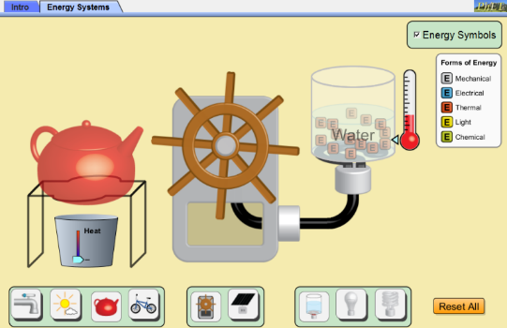 | Turbine moved by cyclist pedaling at medium speed with a fluorescent light bulb system  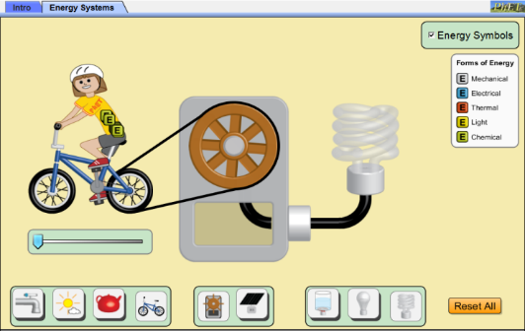

Key Points:
- Number of transformation “steps” depend on the initial and final state of energy system we choose to consider.
- “Energy cannot be created or destroyed; it can only be changed from one form to another.” -- Albert Einstein

6.2 – Energy Bar Graphs
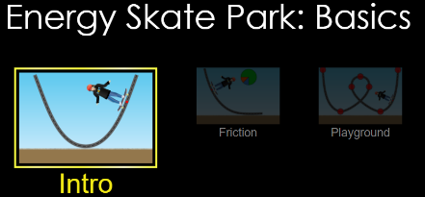
Go to and explore the Phet Simulation called “Energy Skate Park Basics: Intro”.
- Why is the skater’s motion perpetual?

Consider a skater moving back and forth along a frictionless ramp as shown in Frames 1 – 4 below.
- Write the “four” step energy transformation taking place (one for each frame).
_________ _________ _________ _________
- Draw an energy bar chart for various positions given.

Frame 1  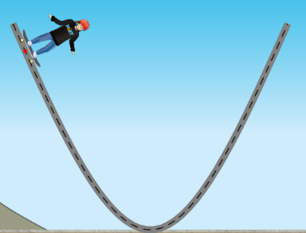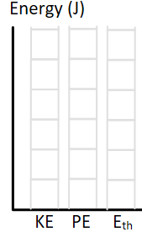 | Frame 2  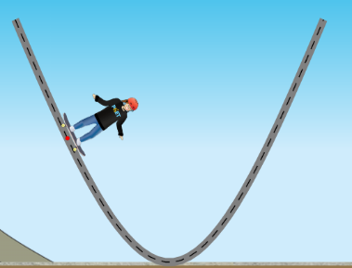
Frame 3  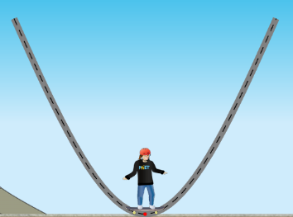 | Frame 4  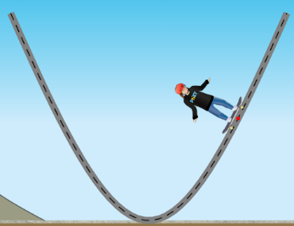

- In the table below, write down whether each quantity increases, decreases, or stays the same.

Skater’s Movement |  | Potential Energy | Kinetic Energy
Up the hill | 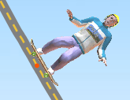  v
Down the hill | 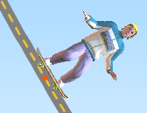  v

Practice: State the “3 step” energy transformation taking place in each situation given.

- An arrow is shot from a bow and stops in the center of its target.  __________ → __________ → __________ | - An object rests on a coiled spring, and is then launched upwards.  __________ → __________ → __________
- A piece of clay is dropped and sticks to the floor.  __________ → __________ → __________ | - A pole vaulter runs, plants her pole, and vaults up over a bar.  __________ → __________ → __________

6.3 – Equations for Kinetic and Potential Energy

- Go online to search for the equations for kinetic and potential energy. State what each variable represents and what unit they need to be in.
Equation for potential energy:

Equation for kinetic energy:

- Which object in the figure below has the most kinetic energy? Show your work.
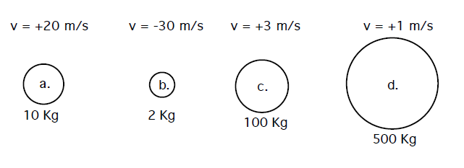
- Which object has the most potential energy relative to the base level indicated?
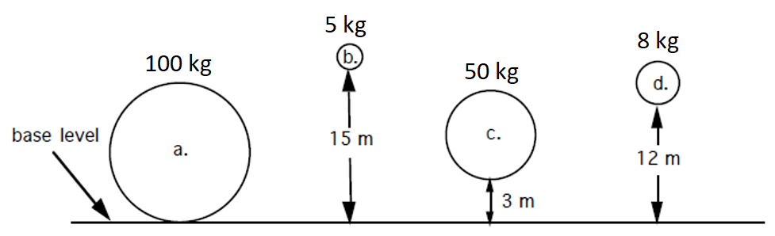
6.4 – Friction

- Open two PhET simulations: (1) PhET Friction Thermodynamics Sim AND (2) PhET Energy Skate Park Basics: Intro Sim
- In the microscopic model boxes, draw and describe the motion of the skater’s molecules at her two different positions. Hint: Think about molecules in the friction simulation.
- In the macroscopic model boxes, draw and describe the energy of the skater at the two positions.

Microscopic Model | Microscopic Model
Macroscopic Model | Macroscopic Model

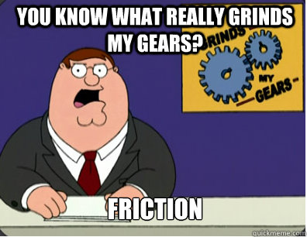

FRICTION SUMMARY:

What happens to the particles when two surfaces are rubbed together?
_______________________________________________________________________________________________________________________________________________________________________________________________________________________________________________________________

- The ___________________ something is moving, the more ___________________ it will create!

- ____________________ energy gets converted to ___________________ energy.

- In other words, ________________ gets converted to __________________.

What are some real life examples where you can observe friction?

6.5 – Total Energy in a System

- Open Phet Energy Skate Park: Basics, and look at the skateboarder on a frictionless ramp (be sure the Energy Bar Graph is open).

- Investigate the meaning of “total energy” from the bar graph. In the table below, describe what the KE, PE, and TE are.
When skater is at top of ramp | When skater is at bottom of ramp | When skater is half way down the ramp
KE = _______________  PE = _______________  E_{TOT} = _______________ | KE = _______________  PE = _______________  E_{TOT} = _______________ | KE = _______________  PE = _______________  E_{TOT} = _______________

- What happens when the element of friction is introduced? Where does all of the energy go?
_______________________________________________________________________________________________________________________________________________________________________________________________________________________________________________________________
- Define “total energy” of the system based on your observations.

- Find a way to increase the “total energy.” What did you do to increase the total energy?

- Use trends in the table from #2 above to write a “rule” about the changes in energy, including total energy, of the system as the skater moves along the track. Use your own words.

- Use your experience with the skater system to complete the energy bar graphs for each position below.

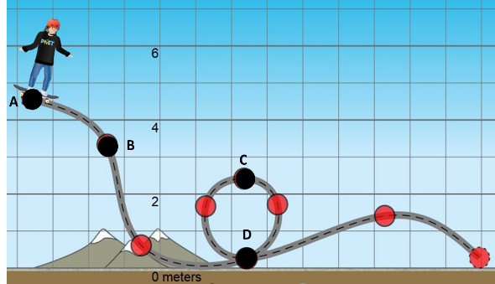

Position A | Position B | Position C | Position D
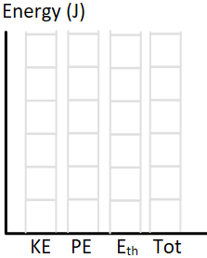

- Based on your observations of total energy at different times and positions, write an equation to show the relationship between the total energy at A and at C. Use the diagrams in #7.

What does the above equation mean? _____________________________________________________ _____________________________________________________________________________________

- Use your observations about the relationship between total energy and the different forms of energy (KE, PE, E_{th}) to build a general equation for the total energy (E_{tot}) in the system.

E_{tot} =

What does the above equation mean? _____________________________________________________ _____________________________________________________________________________________

Example: Use your energy equations to complete the missing information in the table below:

System | E_{tot} at A | KE at A | PE at A | E_{th} at A | E_{tot} at B | KE at B | PE at B | E_{th} at B
 | 16 J | 0 J | 16 J | 0 J |  |  | 0 J | 2 J
 |  |  | 1.1 J | 0.3 J | 24 J | 6.3 J |  | 0.7 J
 |  | 14.5 J | 1 J | 0.5 J |  | 4.5 J |  | 0.9 J

Critical Thinking: In the figures below, balls are travelling in different directions. The balls have the same size and shape, but they have different masses and are traveling at different velocities as shown. Rank the kinetic energy of the balls.

Explain your reasoning:

6.6 – Temperature, Thermal Energy, and Heat

Thermal Energy | Temperature | Heat
An energy of the system due to the __________ of its atoms and molecules. It is the total kinetic energy of moving atoms and it is a form of energy. | A variable that quantifies the ‘hotness’ or “coldness” of a system. It is the average kinetic energy of all the molecules in a substance, or the thermal energy per molecule.  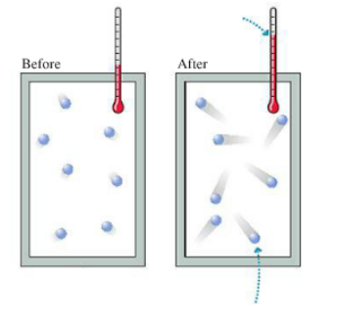  $$Temperature=\frac{E_{th}}{\# molecules}$$ | The energy _________________ between a system and the environment as a consequence of a temperature ________________ between them. Heat is not a property of the system. Instead, heat is the amount of energy that moves between the system and the environment during a thermal interaction.

Consider This: How do the temperatures and thermal energy compare for each of the set ups below?

Temperature
E_{th}

Consider This: Touch your table top. Write an estimate for its temperature: ____________ Touch the table’s metal leg. Write an estimate for its temperature: ______________

Are the temperatures of the table top and the table leg the same? _________________

Consider This: A sparkler is a safe toy for kids as the sparks don’t burn the skin upon contact. In fact, they are quite cool to the touch. In actuality, each spark is 1600°C. Explain why a 1600°C spark doesn’t burn your skin.

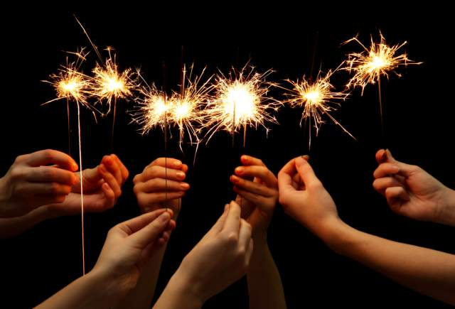

Consider This: An oven at 400°C is much cooler when compared with a sparkler, yet when you accidentally touch the side of the oven while getting your dinner out, it burns quite a bit. Explain why an oven at 400°C burns you significantly more than a sparkler at 1600°C.

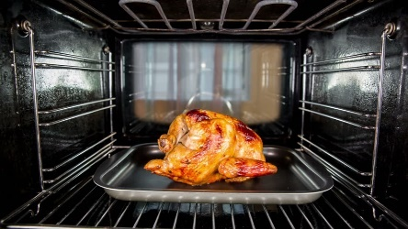

6.7 – Temperature Scales

Temperature scales
- The Celsius scale defines 0 as the point at which _____________________, and 100 the point at which _________________________
- The Kelvin scale defines 0 as _____________________________, the temperature at which
______________________________________________
- The size of one unit of degree Celsius is the _______________ as one unit of degree Kelvin
- Degrees in Kelvin = ______________________

Example: Convert the following.

- What is 25°C in Kelvin? | - What is 0 K in °C? | - What is -32°C in Kelvin?

6.8 – Specific Heat Capacity

Specific Heat is the amount of energy that raises the temperature of 1 kg of a substance by 1 K. You can think of specific heat as thermal inertia. The higher the specific heat (inertia), the more energy (force) needed to change the temperature (velocity).
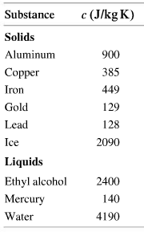
Example: A 70.0 kg student catches the flu, and his body temperature increases from 37°C to 39°C. How much energy is required to raise his body’s temperature? The specific heat of a person is 3400 J/kg K.

Consider This: Consider the following scenarios and discuss with a partner.

- You take a freshly baked apple pie out of the oven that was set at 350°F. What temperature is the pie crust? ________________ What temperature is the pie filling? _________________ Which one burns your tongue more? How come?

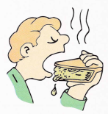

- You find a glass jar with a metal screw top lid difficult to open. Your granny runs the hot water tap over the jar to help you open it. Why might she do that?

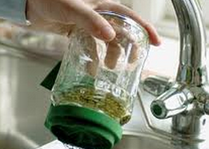

6.9 – Energy Changes in Chemical Reactions

Chemical potential energy: _____________________________________________________________________

In a chemical reaction, there is BOTH bond breaking AND bond making
- bond breaking: _____________________
- bond making: _____________________

Change in enthalpy (ΔH) is the heat consumed or released by a system under constant pressure

 | Endothermic | Exothermic
 | - E bond breaking _____ E bond making  - energy is a _______________  - E of products _____ E of reactants  - ΔH = H_{product} – H_{reactant} = ________________  - on a graph  HCl + 50kJ → H⁺ + Cl⁻  ΔH = | - E bond breaking _____ E bond making  - energy is a _______________  - E of products _____ E of reactants  - ΔH = H_{product} – H_{reactant} = ________________  - on a graph  H⁺ + Cl⁻ → HCl + 50kJ  ΔH =
6.10 – First Law of Thermodynamics

Mini Activity: Let’s explore the two variables in the first law of thermodynamics. You will need 2 x 250 mL beakers, a thermometre, and a glass rod.

Procedure
- Grab a 250 mL beaker and fill half of it with water.
- Try to induce an energy change by ONLY affecting change on Q. Use a thermometer to monitor your success.
- Grat another 250 mL beaker and fill half of it with water.
- Try to induce an energy change by ONLY affecting change on W. Use a thermometer to monitor your success.

