Friction Lab Name:
/10
Procedure:
- In groups of 3, obtain 1 wooden slab, 4 textbooks, and a spring scale.
- For each of the following situations, determine the force needed to move the textbooks at a constant velocity for two different surfaces (desk and carpet). Fill in the table below and show all your work. (2 marks)
 | Number of Text Books | Trial 1 (on desk)  Friction Force (N) | Trial 2 (on carpet)  Friction Force (N)
- Block with 1 textbook

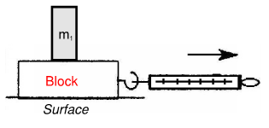

- Block with 2 textbooks

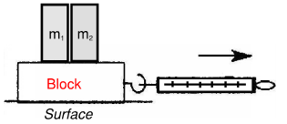

- Block with 3 textbooks

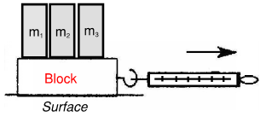

- Block with 4 textbooks

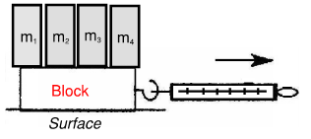

- Plot a graph of Friction force vs. Number of Textbooks. Use triangles for Trial 1 and Squares for trial 2.
- Title your graph
- Label your axes
- Draw a line of best fit through your points
(3 marks)

- What does the slope represent? (1 mark)

- What does a steeper slope in the graph tell you about the surface roughness? (1 mark)

- In your own words, describe what friction is. (1 mark)

- What are some real life scenarios when you would want a high coefficient of friction? (1 mark)

- What are some real life scenarios when you would want a low coefficient of friction? (1 mark)

