Warming Behaviour of Solid Paradichlorobenzene

!! SAFETY PRECAUTIONS !!
- the hot plate gets extremely hot
- heat paradichlorobenzene slowly to avoid shattered glass
- paradichlorobenzene is toxic

Purpose

- To observe what happens when solid paradichlorobenzene is warmed to 70°C
- To graph the heating and cooling curve of paradichlorobenzene
- To determine the melting point of paradichlorobenzene

Background

Paradichlorobenzene is used to control moths, molds, and mildew. It is also used as a disinfectant. The compound accumulates in fat tissue and is environmentally hazardous.

H
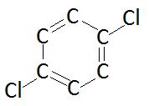
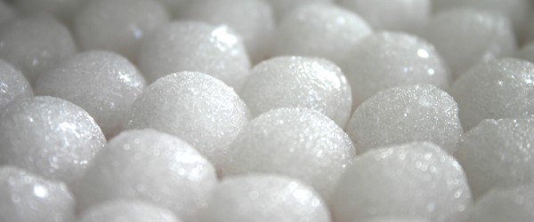
H
H
H

Materials

Equipment  - 500 mL beaker  - 100 mL Erlenmeyer flask  - hot plate  - test tube  - thermometer  - ring stand  - test tube clamp  - timer | Reagents  - paradichlorobenzene

Procedure:

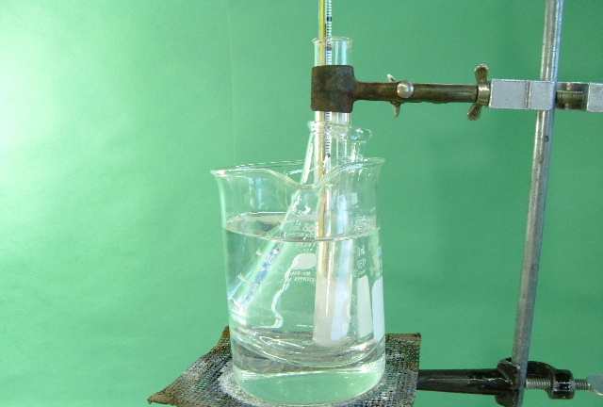
- Get a 500 mL beaker and fill it about half full of tap water to make a hot water bath. Place it on a hot plate and begin heating.
- Put a 100 mL Erlenmeyer flask into the beaker.
- Obtain a test tube with solid paradichlorobenzene and a thermometer in it. Use a test tube clamp to attach this to the ring stand. Put the ring stand next to the hot plate.
- When the water bath is steaming, lower the test tube clamp to lower the test tube into the Erlenmeyer flask. Record the initial temperature. Maintain the water bath at a simmer.
- Record the temperature every half minute until the temperature is above 70ºC. Make a note of the temperature at which the substance first starts to melt, and the temperature at which the substance has completely melted.
- When the temperature has reached above 70°C, turn off the hot plate, and adjust the test tube clamp to lift and swing the test tube with the thermometer away from the hot water bath to begin cooling.
- Record the temperature every half minute until the temperature reaches room temperature. Make a note of the temperature at which the substance first starts to solidify, and the temperature at which the substance has completely solidified.
Results

Using Excel, plot a “scatter with smooth lines and markers” of time vs. temperature.
- Title your graph as “Heating & Cooling Curve of Paradichlorobenzene” (1 mark).
- Label the axes with Temperature (ºC) and Time (min) (1 mark).
- Ensure that each data point is visible on the graph (1 mark).
- Label the melting point on your graph (1 mark).
- Label on your graph when paradichlorobenzene is a solid and liquid (1 mark).
- Label on your graph where paradichlorobenzene is changing from solid to liquid, and vice versa (1 mark).

Discussion

- What is happening to the molecules at the plateau of the graph? (1 mark).
- What is happening to the molecules at the slopes of the graph? (1 mark).
- Predict what the graph would look like if you continued to heat the liquid paradichlorobenzene well past its melting point. Sketch the graph and label the following:
- Phase transitions (1 mark).
- Where paradichlorobenzene is solid, liquid, and gas (1 mark).
- Boiling point and melting point (include the temperature) (2 marks).
- Predict what the graph would look like if you started from gaseous paradichlorobenzene and waited for it to solidify. Sketch the graph and label the following:
- Phase transitions (1 mark).
- Where paradichlorobenzene is solid, liquid, and gas (1 mark).
- Condensation point and freezing point (include the temperature) (2 marks).
- Why did we put the test tube inside an Erlenmeyer flask? Why not just directly submerge the test tube in the hot water? (1 mark).

