Separations of Mixtures

!! SAFETY PRECAUTIONS !!
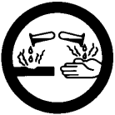
- Iodine will stain skin and clothes. Be careful not to dirty your uniform against the table.
- Iodine is also an irritant for skin and eyes.

Purpose
To investigate which separation techniques are appropriate for various types of mixtures.

Station 1: Filtration

- Fold two pieces of filter paper and place one in each of the two funnels.
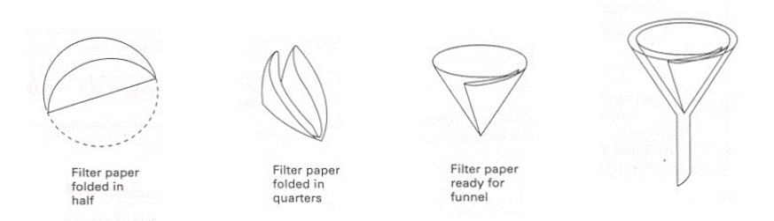
- Place each funnel over a clean beaker using the ring clamp.
- Make Mixture A by dissolving a scoop of compound A into a beaker of water.
- Make Mixture B by dissolving a scoop of compound B into a beaker of water.
- Filter Mixture A in one funnel, and B in the other.
- Observe the filter papers and the beakers below the funnel and answer the questions on your handout.
- When finished, discard the filter papers in the garbage and clean out each beaker.

Station 2: Distillation

- Observe what is happening at this station and answer the questions on your handout.

Station 3: Gravity Separation

- Examine what makes a particle sink faster by dropping various particles into the graduated cylinder of water.
- The rest of the station will be done as a demo. Watch and record observations.

Station 4: Solvent Extraction

- Add water to a large test tube until the water level is 4 cm.
- Using a scoopula, add a few crystals of iodine to the water.
- Put a rubber stopper on the test tube and shake to dissolve the iodine as much as possible. You now have a mixture and your task is to separate the iodine from the water.
- Make sure the separatory funnel is empty and the stopcock is closed. Remove the stopper at the top and pour the contents of your test tube into the separatory funnel. Do not pour any undissolved iodine into the funnel.
- Add ~5 mL of petroleum ether into the separatory funnel, or enough to see a nice 1 layer in the separatory funnel.
- Put the stopper on the separatory funnel, and shake the separatory funnel to mix all the contents together. Every few shakes, remove the stopper to release pressure, then replace and continue shaking.
- Put the separatory funnel back on the ring stand and remove the stopper. Wait for the contents to settle.
- Place a beaker underneath the separatory funnel and open the stopcock to drain just one layer of the contents.
- When finished, pour everything into the waste beaker and answer the questions on the handout.

Station 5: Recrystallization

- This station will be done as a demo. Watch and record observations.

Name: _______________________________ Block: ______

Separation Techniques

Station 1: Filtration

- Label the diagram below with the following: funnel, filter paper, ring clamp, ring stand, filtrate, beaker (3 marks).

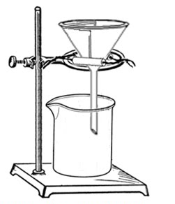

- What type of mixture is Mixture A? _________________________________________ (1 mark).

- What type of mixture is Mixture B? _________________________________________ (1 mark).

- Filtration was able to separate the components in Mixture ______, but not Mixture ______ (1 mark).

- Consider the size of the particles in Mixture A and B and give a reason why one filtration failed (1 mark).

Station 2: Distillation

- Given the diagram below,
- Label the following: distillation flask, distillate, mixture, condenser (2 marks).
- Draw arrows on the diagram showing the movement of the mixture as it is being separated into its components (1 mark).

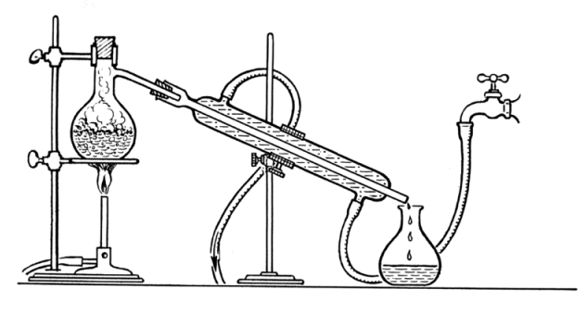

- The mixture in the distillation flask is a ____________________________________________ of food
homogeneous mixture / heterogeneous mixture
colouring and water. The _________________ is boiling but the _________________________ is not. The water and food colouring must have different _________________________________ (4 marks).

- Touch the condenser. Is it hot or cold? _________________________ (1 mark).

- What is circulating in the condenser’s outer jacket? ___________________________________ (1 mark).

- What is happening inside the glass tube in the condenser? What is the purpose of the condenser? What would happen if a condenser was not used? (2 marks).

- Besides water and food colouring, give another example of a mixture that can be separated using distillation. ________________________________________ (1 mark).

Station 3: Gravity Separation

- What are some factors that determine how fast a particle sinks in water? In other words, why do some particles fall faster than others? (2 marks).

- Sketch a quick picture of the demo test tube before centrifugation, and after centrifugation. In the “after” picture, try to identify the layers by labelling them. Listen to Ms. Kelsall and jot down a few notes on what is found in each layer (3 marks).

Before | After Centrifugation

- Write some notes on Ms. Kelsall’s talk. Why do we have to spin blood? (2 marks)

Station 4: Solvent Extraction

- Is iodine highly soluble in water? __________________________________________________ (1 mark).

- What colour is the iodine water mixture? ___________________________________________ (1 mark).

- What type of mixture is the iodine water mixture? ____________________________________ (1 mark).

- In a solution, the solvent is the liquid, and the solute is the substance that is dissolved. In the water iodine mixture, the solvent is _______________ and the solute is _______________ (1 mark).

- After the addition of petroleum ether and subsequent shaking (after step 7)
- Describe what happens (1 mark).
- Sketch a picture of what the separatory funnel looks like (1 mark).
- Label what compounds are in each of the layers in your drawing (1 mark).

- In the mixture of water, iodine, and petroleum ether, the solvents are ________________ and ________________________________, and the solute is ______________. Between the two solvents, ____________________________ is the better one to dissolve iodine because we observed that
_____________________________________________________________________________________
____________________________________________________________________________ (3 marks).

- In order for solvent extraction to work, _________ solvents are usually present. The solvents must be
#
______________________________with each other (2 marks).
^{miscible / immiscible}

Station 5: Recrystallization

- What type of mixture is it before heating? __________________________________________ (1 mark).

- What type of mixture is it after heating? ____________________________________________(1 mark).

- What happens when the mixture is cooled? _________________________________________ (1 mark).

- What is the solvent? ___________________ (1 mark).

- What separation technique can be used after recrystallization to separate the crystals from the solvent?
________________________________________ (1 mark).

- The compound that crystallizes is lead (ll) iodide. The formula is _____________________ (1 mark).

- Are the isolated crystals pure, or a mixture? Explain (1 mark).

