Percent Composition Lab– Oreo Activity
Is Double Stuffed REALLY Double Stuffed?
Name: ______________________
Date: _____________________
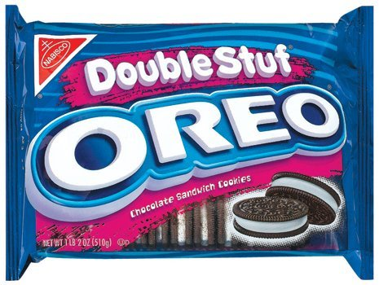
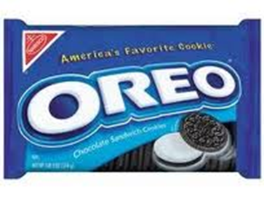

A specific brand of cookie (beginning with the letter O made by Mr. C) claims that their double-stuffed cookie contains twice the amount of filling as their regular brand. But is this claim really true? To better understand the concept of Percent Composition, we are going to study Mr. C’s claim.
PURPOSE: To determine if double stuffed cookies contain twice the amount of creamy goodness.
HYPOTHESIS: If _____________________________________________________________, then _______________________________________________________________
MATERIALS:

- 1 regular Oreo
- 1 double stuffed Oreo
- Balance
- Knife
- Napkin

PROCEDURE:

DATA TABLE:

Regular Oreo ____________________ ______________________
% Wafer % Filling
Double Stuffed ____________________ ______________________
Oreo % Wafer % Filling

CONCLUSION:
- Was your hypothesis supported or disproven? Explain how you know.

- In order to answer Question 1, did you use the mass of the cream filling OR % composition of the cream filling? Explain your reasoning.

- Come up with a formula to explain how you can find percent composition using mass.

- How is Percent Composition of a molecule by atoms different then Percent Composition of a molecule by mass of? Explain using a molecule as an example.

EXTRA QUESTIONS
Find the percent composition by mass of the bold atom and ONLY the bold atoms in the following compounds:
- Ammonium phosphate – (Hydrogen)

- Mg(NO₃)₂

- Potassium permanganate – (Oxygen)

- Calcium hydroxide

