3-D Cell Analogy Model

Group: _________________________________________________________ Block: ______

We will be spending the next few classes working on a 3-D Cell Analogy Model (of a plant or animal cell). You will use an analogy of your choice to represent a cell, create a 3-D visual display, and label how all parts of a cell are similar to the functions of your analogy.

You have the choice of working on this with a partner or on your own. You will be expected to plan out your cell model in class, make a list of supplies that you need, and bring them into class to work on your model during class time.

You are REQUIRED to bring your supplies to class on: ______________________________

The project is due on: ________________________________

Procedure:
- Design an analogy to explain the functions of a cell and present it on PowerPoint.
Example Slide 1: We are comparing the Cell to a School.

- Compare the functions of the cell organelles with the features of your analogy. This will be done on PowerPoint in your Science 8 folder on Google Drive. Use one slide per organelle. You can use the following template:
Example Slide 2: In our cell model, the Headmaster represents the nucleus in our cell model analogy. In the cell, the nucleus is the control centre of the cell. This is similar to the Headmaster because they both need to provide instructions and direct activities.

Example Slide 3: The school custodians represent the lysosomes. In the cell, the lysosomes digest waste material. This is similar to the custodians because they clean up the school.

- Build a 3-D model of your analogy and clearly label all organelles and structures of a cell in your display.

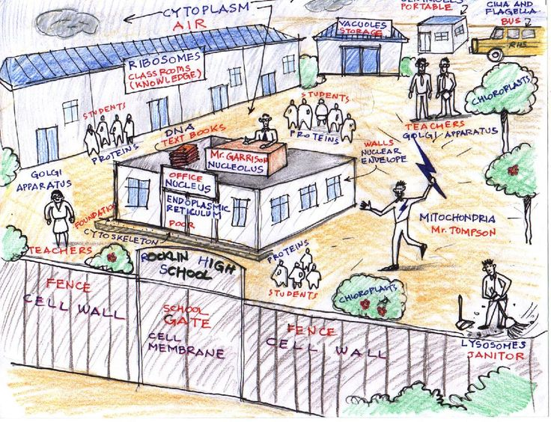

Each model must include ALL organelles learned in class: Use the checklist below to keep track!

Animal | Plant
- Cell membrane  - Ribosomes  - Nucleus  - Mitochondria  - Vacuoles  - Vesicles  - Cytoplasm  - Golgi Body  - Endoplasmic Reticulum  - Lysosomes | - Cell membrane  - Cell wall  - Ribosomes  - Nucleus  - Mitochondria  - Vacuoles  - Vesicles  - Cytoplasm  - Golgi Body  - Endoplasmic Reticulum  - Lysosomes  - Chloroplasts

Cell Analogy Model Criteria

Group: ___________________________________________ Block: ______

 | Below Expectations | Meets Expectations | Above Expectations | Student Mark | Teacher Mark
Use of class time | (1-2)  Student not using class time productively, did not come to class prepared with materials. | (3-4)  Student is on task most of the time, comes to class prepared with materials most of the time. | (5)  Student in always on task, comes to class prepared with materials
Creativity | (1-2)  Little imagination model design simple with minimal effort, unsuitable analogy. | (3-4)  Some creativity shown in model of fair to good quality, analogy is common. | (5)  Imaginative to highly original model, good use of available materials, well thought out, uncommon analogy.
Representation and Labeling | (1-2)  Many structures are not properly labeled and/or compared to the structures and functions of the cell. | (3-4)  Most structures are properly labeled and compared to the structures and functions of the cell, either on the display or as an appendix. | (5)  All structures are properly labeled and compared to the structures and functions of the cell, either on the display or as an appendix.
Model Construction | (1-4)  The cell model is satisfactorily put together. Improvement is needed in the construction and choice of materials. | (5-8)  The cell model is neatly put together. Some effort is evident in the construction and choice of materials. | (9-10)  The cell model is neatly and carefully put together. Much effort is evident in the construction and choice of materials.
Google Slides | (1-8)  The Google Slide presentation may not be completed for each organelle. The descriptions for the organelles are incomplete or lacking detail. | (9-12)  The Google Slide presentation is completed for each organelle. The descriptions for each organelle are adequate but some if not all are lacking in detail. | (13-15)  The Google Slide presentation is completed for each organelle. The descriptions for each organelle are very detailed and accurate.
 |  |  | TOTAL | /40 | /40

Cell Analogy Model Marking Sheet

Group: ___________________________________________ Block: ______

 | Below Expectations | Meets Expectations | Above Expectations | Student Mark | Teacher Mark
Use of class time | (1-2)  Student not using class time productively, did not come to class prepared with materials. | (3-4)  Student is on task most of the time, comes to class prepared with materials most of the time | (5)  Student in always on task, comes to class prepared with materials
Creativity | (1-2)  Little imagination model design simple with minimal effort, unsuitable analogy. | (3-4)  Some creativity shown in model of fair to good quality, analogy is common. | (5)  Imaginative to highly original model, good use of available materials, well thought out, uncommon analogy.
Representation and Labeling | (1-2)  Many structures are not properly labeled and/or compared to the structures and functions of the cell. | (3-4)  Most structures are properly labeled and compared to the structures and functions of the cell, either on the display or as an appendix. | (5)  All structures are properly labeled and compared to the structures and functions of the cell, either on the display or as an appendix.
Model Construction | (1-4)  The cell model is satisfactorily put together. Improvement is needed in the construction and choice of materials. | (5-8)  The cell model is neatly put together. Some effort is evident in the construction and choice of materials. | (9-10)  The cell model is neatly and carefully put together. Much effort is evident in the construction and choice of materials.
Google Slides | (1-8)  The Google Slide presentation may not be completed for each organelle. The descriptions for the organelles are incomplete or lacking detail. | (9-12)  The Google Slide presentation is completed for each organelle. The descriptions for each organelle are adequate but some if not all are lacking in detail. | (13-15)  The Google Slide presentation is completed for each organelle. The descriptions for each organelle are very detailed and accurate.
 |  |  | TOTAL | /40 | /40

