Problem Set 9.2: Intermolecular Forces

Chemical bonds within molecules are intramolecular forces (“Intra” means within). Attractive forces between molecules and between ions and molecules are called intermolecular forces. These occur in liquids and solids.

Below are a few types you will need to know!

A. Dipole-Dipole Forces
- Within any substance containing polar molecules, each molecule has a partial positive and partial negative pole (a molecular dipole).
- This arises when electronegative elements (O, N, halogens) are bonded to less electronegative species.
- This causes the molecules in a liquid or solid phase to orient themselves with the positive pole of one molecule being next to the negative pole of the next. This is called a DIPOLE-DIPOLE FORCE!
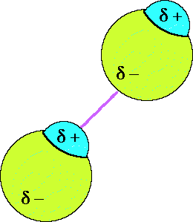

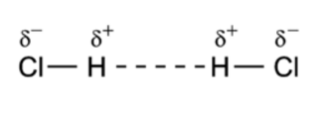

Ex. Two HCl molecules interacting

B. Hydrogen Bonds (special dipole-dipole forces)
- There is one type of dipole-dipole interaction which is especially strong. It is called a hydrogen bond (H-bond).
- The partial negative charge (δ- ) comes from one of the electronegative elements F, O or N. The atoms of these second period elements are small, highly electronegative, and have lone electron pairs. These are called H-bond acceptors.
- The partial positive charge (δ+ ) comes from an H bonded directly to one of these elements (O-H, N-H, F-H). These are called H-bond donors.
- Both a donor and an acceptor are needed to form an H-bond. These are stronger IMF than dipole-dipole interactions.
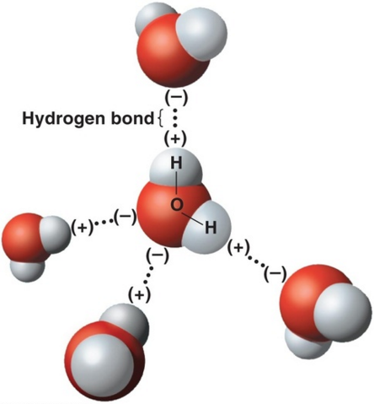

Ex. A diagram showing 4 hydrogen bonds between water molecules

C. London Dispersion Forces (LDF)
- For a molecular substance to exist as a liquid or solid, the molecules must be close together. This means some kind of intermolecular attractive force must exist between those molecules (even non-polar molecules!).
- In all molecules the electrons are constantly moving around, which sometimes causes more electron density on one side of the atom than the other. This slight imbalance results in an instantaneous dipole moment.
- All atoms and molecules possess LDF, which increase with the size and the number of electrons in the molecule.
- These are very small, very short-lived charges.

Practice Problems

1) Using your knowledge of molecular structure, identify the main intermolecular force in the following compounds. You may find it useful to draw Lewis structures to find your answer.

a) PF₃ _____________________________

b) H₂CO ___________________________

c) HF _____________________________

d) CH₄ ____________________________

e) NH₃ ____________________________

f) H₂S ____________________________

g) N₂H₂____________________________
h) BH₃ ____________________________

2) Explain how dipole-dipole forces cause molecules to be attracted to one another.

3) Explain why nonpolar molecules usually have much lower surface tension than polar ones.

4) Which of the following pairs of compounds can form H-bonds? For those that can, mark the position of the partial positive (δ+ ) and negative (δ- ) charges in the molecules and indicate where the H-bonds will form. For those that can't form H-bonds, describe the strongest Intermolecular Force available to that pair of compounds.
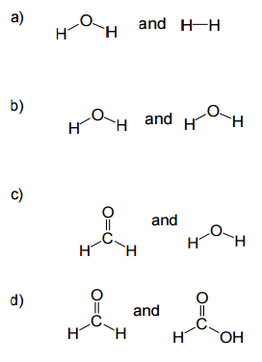

5. Identify two examples of how hydrogen bonding between water molecules makes life on earth possible (you may need to do some research for this one!).

