6.1-6.5 Review

- Fill out the following chart on the 5 main types of energy

Form of Energy | What is it? | Examples
Nuclear

 | The majority comes in the form of light and heat; created from fusion of hydrogen
 |  | Baking a cake; powering cars
 | Sum of Kinetic + Potential Energy
 |  | Digesting food; photosynthesis

- Using the diagram below, state the different energy transformations that you think would occur:
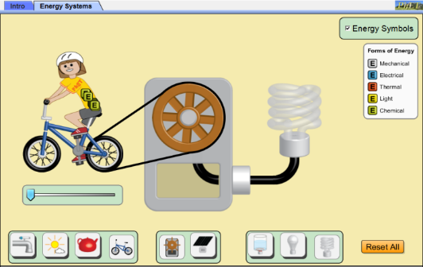

__________________ ___________________ ___________________ __________________

- Write a sentence to summarize energy transformations using the following words: Energy, change, created, destroyed

__________________________________________________________________________________________________________________________________________________________________________________________________________________________________________

- Complete the following energy bar graphs for the skateboarder.

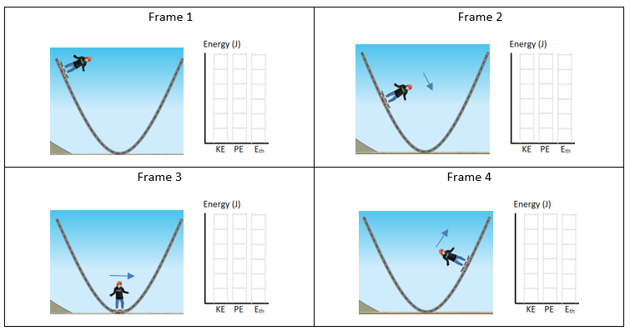

- What energy transformations are taking place in the following scenarios?
  - A rabbit eats some lettuce that is growing in the ground

  - A battery operated flashlight gets turned on

  - A student rides their bicycle along a flat path to school

  - A soccer player kicks a soccer ball

- Answer the following kinetic and potential energy questions. Be sure to include your formula and units in your final answer for full marks!
  - The largest land predator is the male polar bear, which has a mass of around 500.00 kg. If the top speed of a male polar bear is 11.0 m/s, how much KE does it have?

  - An object has a kinetic energy of 25 J and a mass of 34 kg, how fast is the object moving?

  - What is the mass of a baseball that has a kinetic energy of 105 J and is traveling at 10 m/s?

  - What is the velocity of a roller coaster if it has 1,200,000J of energy and a mass 1200kg?

  - A 120kg bicycle is at the top of a 12m hill. What is the bicycle's potential energy?

  - A box has a mass of 5.8kg. The box is lifted from the garage floor and placed on a shelf. If the box gains 145J of Potential Energy (Ep), how high is the shelf?

  - A man climbs on to a wall that is 3.6m high and gains 2268J of potential energy. What is the mass of the man?

  - A 800g ball is pulled up a slope as shown in the diagram. Calculate the potential energy it gains.
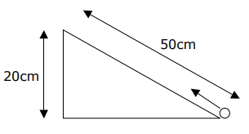

- What happens to the particles of an object when it rubs against another surface?

- The faster/slower something is moving, the more/less friction it creates.

- When discussing friction, _____________ energy gets transformed into _____________ energy.

- When would you want a high coefficient of friction?

- When would you want a low coefficient of friction?

- Define “total energy” of a system.

- Use the following picture to answer the questions
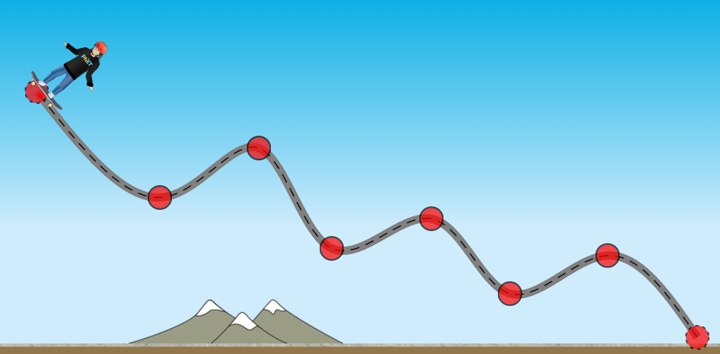
D
C
A
B

  - At which point is PE the highest? Explain why.

  - At which point has the most energy been converted to thermal? Explain.

  - Describe which types of energy are present at point B.

  - Discuss the total energy between points A and C. Explain what types are present at each.

