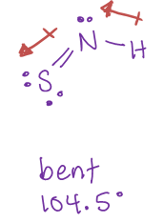**REVIEW FOR QUIZ - Answer Key**

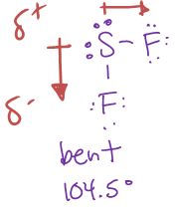

1. D ii)

Bent

104.5°

Polar

Dipole-dipole

Bent

104.5°

Polar

Dipole-dipole

1. 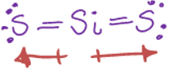d iv) 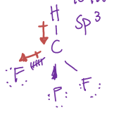

Tetrahedral

104.5°

Polar

Hydrogen bond

Linear

180°

Non-Polar

LDF

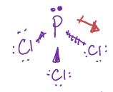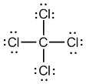 vi)

Trigonal pyramidal

107°

Polar

Dipole-dipole

Tetrahedral

104.5°

Non-Polar

LDF

v)

viii)

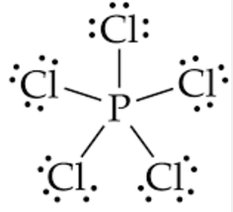vii) 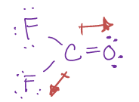

Trigonal bipyramidal

90°, 120°, 80°

Non-Polar

LDF

LDF

Trigonal planar

120°

Polar

Dipole-Dipole