PHYSICS TEST REVIEW
- What is the difference between thermal energy, heat, and temperature?

- Describe how something that is 15°C can have more thermal energy than something that is 30°C.
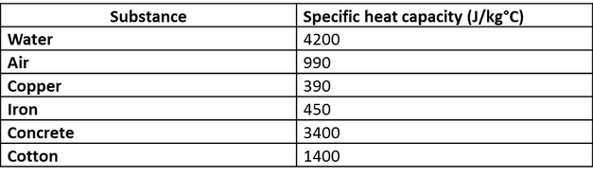
- What are the units for specific heat capacity?

- What is the unit for energy?

- How much energy is needed to heat up 1kg of water by 15°C?

- How much energy would be needed to raise the temperature of a 5kg block of concrete by 10°C?

- Can you calculate the energy needed to increase the temperature of 100kg of iron by 40°C?

- A 20kg concrete block is at 20°C and is heated to 65°C. What is the energy used to heat this block?
- A 250g copper pipe is heated from 10°C to 31°C. What is the energy needed to heat the pipe?
- What will be the temperature change if you used 1125J of energy to heat a block of iron weighing 0.5kg?
- Given 132.8J of energy is required to heat 11.17g of aluminum from 15.73°C to 28.94°C find the specific heat capacity of aluminum.
- Given the specific heat capacity of lead is 0.129 J/g∙K and that it takes 93.4J of energy to heat a sample of lead from 22.3°C to 40.4°C find the mass of the lead.
- Given that the specific heat capacity of copper is 0.385J/g∙K and if 81.2J of heat is applied to 17.8g of copper by how much will the temperature of the copper increase?
- If I have 2 blocks of Aluminium (one of 1kg and one of 10 kg) and heat them up.
Which one heats up the fastest? Explain your answer.
- What has a higher temperature, the metal seatbelt in your car on a sunny day, or the fabric of the seat? Explain.
- What is the temperature that water boils at in Kelvin?
- What is the temperature that water freezes at in Kelvin?
- If something is 302 K, what is the temperature in Celcius?
- Discuss how specific heat capacity of the oceans affects Vancouver’s climate.
- Why is the high specific heat capacity of water a good thing for the animals and plants living in the ocean?

