Genetic Mutations
Name: ________________________
Date: ________________________

Basic Vocabulary

A gene mutation, or mutation for short, is a change in the genetic material (DNA) of a gene.

Think: What might be some consequences of mutations?

While mutations are naturally occurring, there are also factors in the environment, called mutagens, can that can cause mutations.
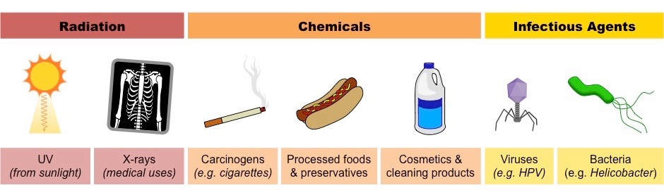

Some mutations can be helpful to an organism. Helpful mutations are called _______________ _____________.
An example of this is __________________________________________________________________________ ___________________________________________________________________________________________

Most mutations have no effect on an organism. These mutations are called _____________ ________________.
An example of this is __________________________________________________________________________ ___________________________________________________________________________________________
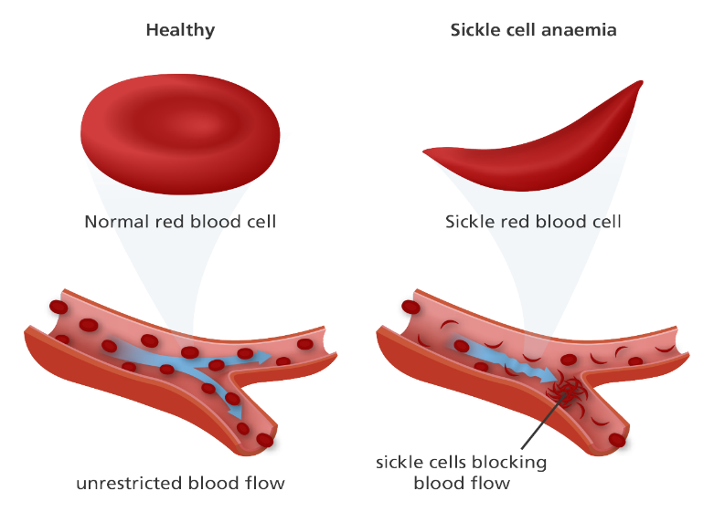
Some mutations can be harmful to an organism. Harmful mutations are called _____________ _______________.
For example, _______________________________ __________________________________________
__________________________________________
__________________________________________
__________________________________________
__________________________________________
- Use the words in the word bank below to fill in the blanks. Each term may be used more than once, or not at all.

DNA  gene mutation  gene therapy  organism | healthy gene  mutagens  mutated gene  proteins | negative mutations  neutral mutations  positive mutation

- A is a change in the genetic material of a gene.

- Changes to DNA may cause _______________to be made incorrectly or with an incorrect shape.

- Factors in the environment, called _________________ can cause mutations.

- Radiation, cigarette smoke, and pesticides are examples of ____________________________.

- Mutations that are harmful to an organism are called ________________________________.

- Mutations that are helpful to an organism are called _________________________________.
For instance, some plants carry a mutated gene that protects them from disease.

- Mutations that have no effect on an organism are called ______________________________.

- New techniques for treating gene mutations are called ____________________________ and may involve replacing a _________________________ with a _________________________.

- Mutations can result from exposure to mutagens, however, they can also happen in the body naturally. How might this occur?
Basic Types of Mutations

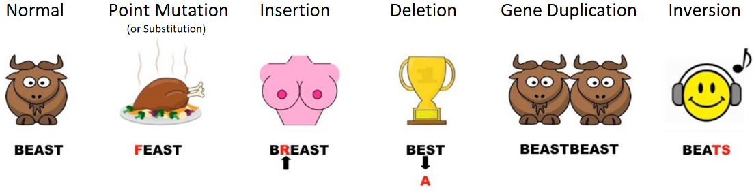
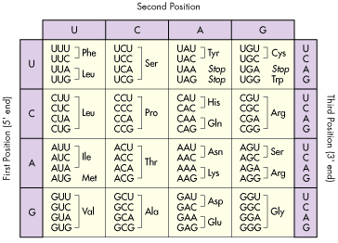
- A portion of the genetic sequence for a strand of your DNA is shown below. The gene expressing protein X is in bold.

AATTGTCCTACTGATCGACCCCCACTGCTTAGCGC

- What is the mRNA strand of this gene sequence and what amino acids would this translate to?

- What would happen to the amino acid chain if the T indicated by the arrow is mutated to A?

- What would happen to the amino acid chain if the T indicated by the arrow is deleted?

- What consequences might result if there were to be a point mutation at the final T in the DNA sequence to C?

- If there was a deletion mutation of the TAC region of the gene, what would be a consequence? Explain.

RESEARCH: What is the difference between a silent mutation, a nonsense mutation and a missense mutation?

RESEARCH: What type of mutation: point, insertion, or deletion, will have the greatest impact on your genetic sequence when coding for a protein? Find an example that supports your explanation.

RESEARCH: Describe three different types of chemical mutagens. What kinds of mutations would each cause, and how?

