Unit 4
Genetics

What are Traits?
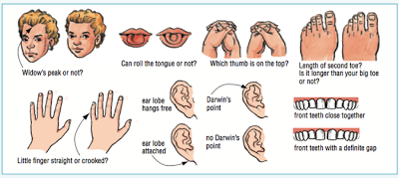
Traits: Brainstorm with a partner – Where do traits come from? Who and What are responsible for these traits?

Watch: http://learn.genetics.utah.edu/content/basics/traits/
Define the following terms:
Genetics
Inherited traits
Non-inherited traits
Heredity
Genome

How is Genetic Material Inherited?
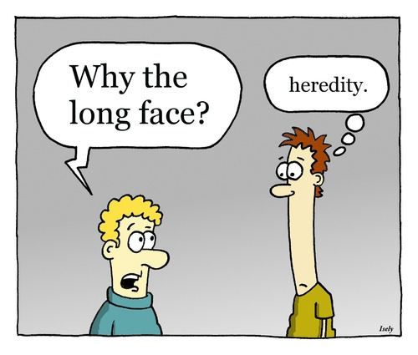
- Inheritance describes how genetic material is passed on from ___________ to ____________.
- We get one copy of our ________________ from each of our parents.
- Most of our cells contain two sets of _____ chromosomes? (they are _________________).
- An exception to this rule are the sex cells (egg and sperm), also known as _______________, which only have one set of chromosomes each (they are ________________).
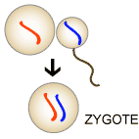
- However, in sexual reproduction the sperm cell combines with the egg cell to form the first cell of the new organism in a process called _________________________.
- This cell (the fertilized egg) has two sets of ______ ________________(diploid) and the complete set of instructions needed to make more cells, and eventually a whole person.
- This passing down of genetic material is evident if you examine the _________________ of members of the same family, from average height to hair and eye colour to nose and ear shape, as they are usually similar.
Structure and Function of DNA (Review from Grade 9)

Check Background Knowledge: What do we remember about the structure & function of DNA?

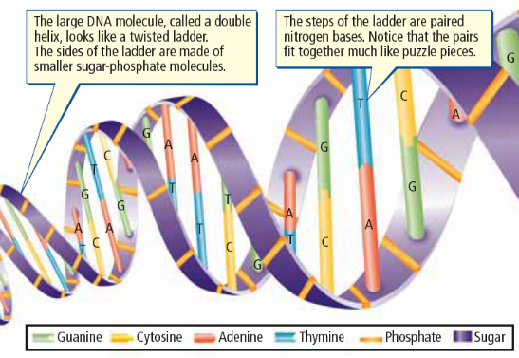
DNA carries the master set of instructions for cell function

- DNA stands for ________________________ __________

- Stores the _____________ _______________________ of an organism

- Genetic information determines how an organism ________, ______________, and _______________.
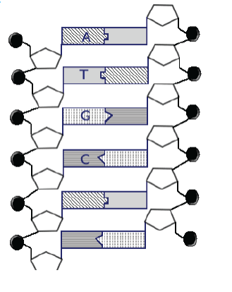
DNA: Structure
- Two long strands shaped like a _______________ _______________________
- Consists of many copies of four different chemical building blocks called ____________________: adenine (A), thymine (T), cytosine (C), guanine (G)
- DNA sequence: The specific order of ___________________; the “code” that holds the genetic information.

Use the image at the right to complete the follow:
Circle a nucleotide.
Label the sugar and phosphate.
Label the bases that are not already labeled.

DNA: Function
- Stores the ___________ ___________________ of an organism
- An organism’s DNA is stored in each of its _____________.
- DNA molecules coil and compact into a condensed form called _______________ to fit into the cells
- Just before reproduction: DNA condenses further into structures called _______________________
- During reproduction: Copies of chromosomes (and therefore DNA) are transferred the ________________________.

Watch: https://www.youtube.com/watch?v=xUrlreMaUrs

Label the diagram below using the terms: chromosome, DNA and chromatin
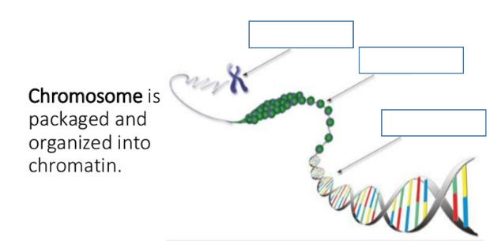

Protein Synthesis

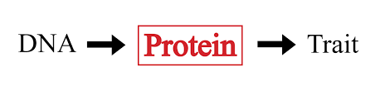  A ___________ is a segment of DNA that codes for a specific __________. __________ __________________ occurs in two phases.  Phase 1: Transcription in the ______________  - _____________________  Phase 2: Translation in the ______________  - _____________________ | 